Research and Evaluation, International
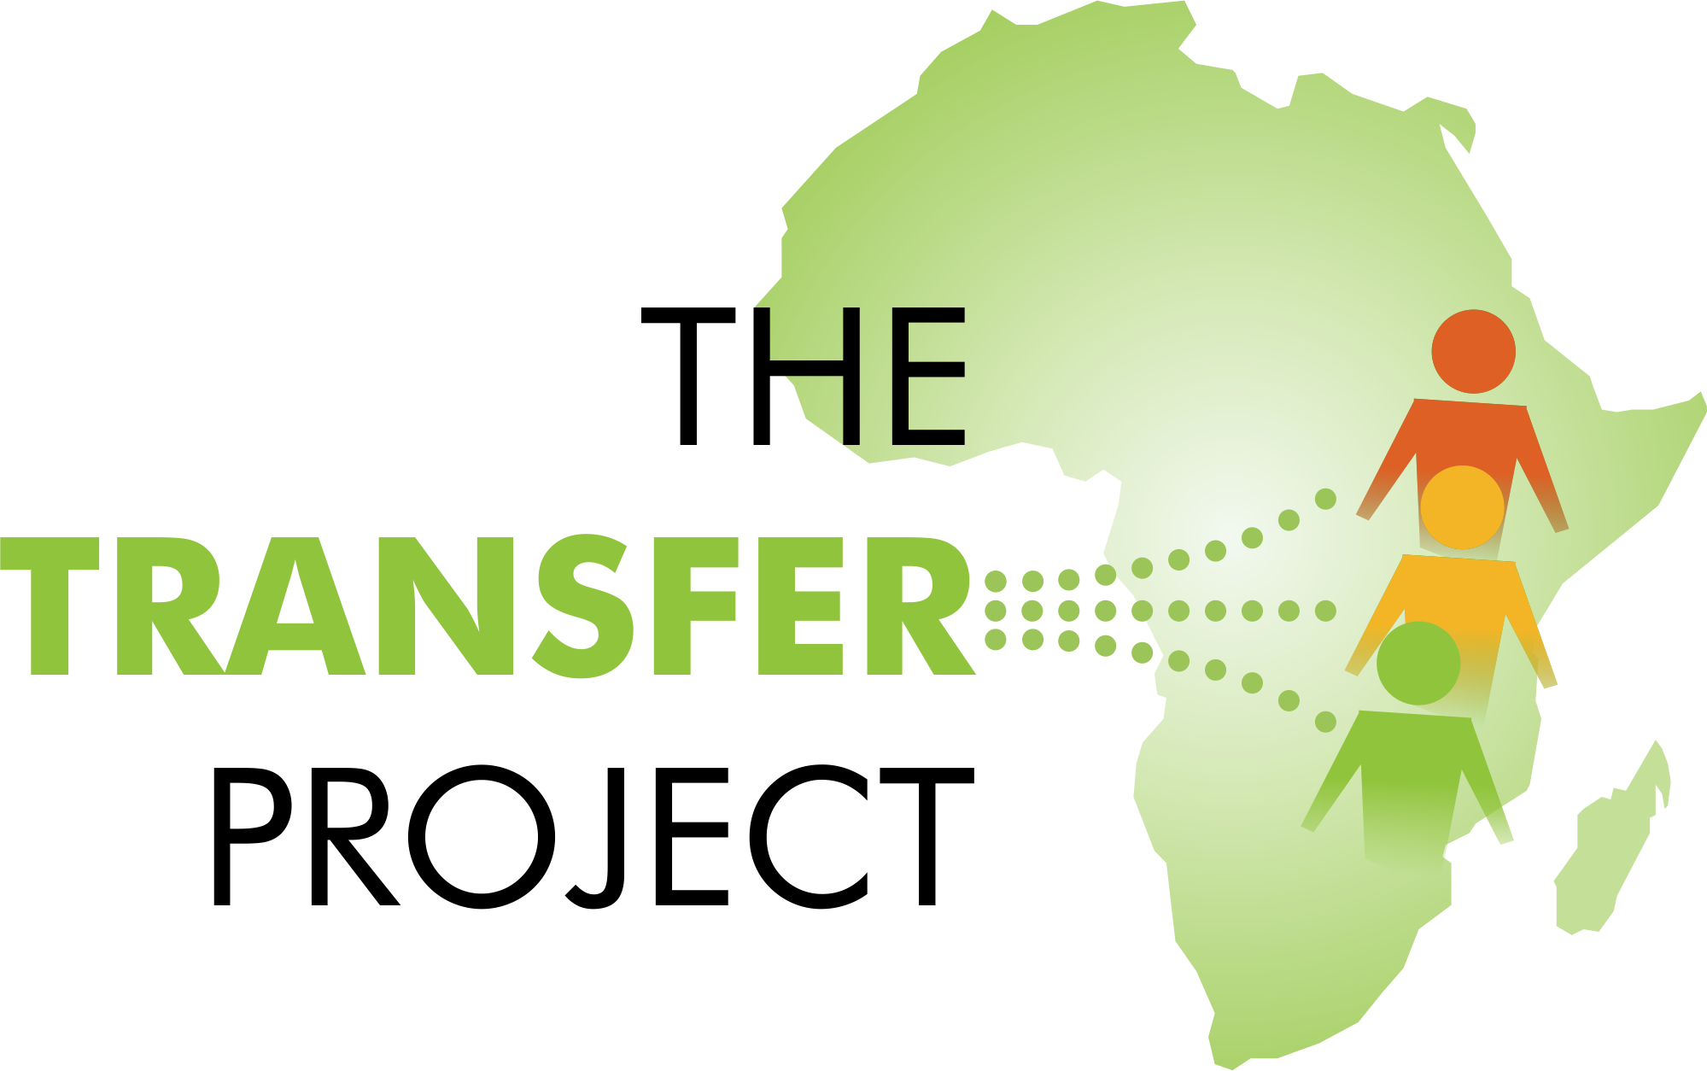
FEBRUARY 2017

Evaluation of Min Ila, a UNICEF and WFP Cash Transfer Program for Displaced Syrian Children in Lebanon
Baseline Report

Evaluation of Min Ila, a UNICEF and WFP Cash Transfer Program for Displaced Syrian Children in Lebanon

Baseline Report
February 2017
Jacobus de Hoop, UNICEF Office of Research - Innocenti
Mitchell Morey, American Institutes for Research
David Seidenfeld, American Institutes for Research

1000 Thomas Jefferson Street NW
Washington, DC 20007-3835
202.403.5000
www.air.org
Copyright © 2017 American Institutes for Research. All rights reserved.

Contents
Page
Abbreviations and Acronyms iv
Acknowledgments v
Executive Summary vi
I. Introduction 1
Background 1
Evaluation 1
Objectives of the Study 2
II. Context 3
Out-of-School Children 3
Barriers to Enrollment 3
Child Labor and Early Marriage 4
Existing Interventions 4
Review of the Evidence 5
III. Theory of Change 7
Activities 7
Pathways to Impacts 7
IV. Study Design 10
Sampling 12
Power Analysis 12
V. Overview of Baseline Data Collection 14
Outcomes and Measures of Interest 14
Training and Piloting 14
Data Collection 15
VI. Sample Description 18
Children Aged Five to Nine Years Old 18
Children Aged 10 to 14 Years Old 21
Demographics 25
Housing 28
Economic Well-Being 29
Adults 31
VII. Comparison to National Statistics 33
Demographics 33
Housing 33
Economic Well-Being 34
Child Outcomes 34
VIII. Baseline Equivalence 35
IX. Conclusion 37
Baseline Equivalence 37
Limitations 38
Timeline for Next Steps 39
X. References 40
Appendix A. Baseline Equivalence Test by Domain 41
Appendix B. Identification Strategy: Geographical regression discontinuity design 45
Regression specification 46
Testing the validity of the geographical RDD 47
Trends in living standards 47
Trends in Food Security 48
Trends in School Enrollment 50

Tables
Page
Table 5.1. Topics in Survey Questionnaire 14
Table 5.2. Training Timeline 15
Table 6.2. Household Demographics 25
Table 7.1. Summary of Comparisons Between the Cash Transfer Study Sample and the VASyR Sample 34
Table 8.1. Housing Differences 36
Table 8.2. Differences in Economic Well-Being 36
Table A.1. Household Demographic Characteristics 41
Table A.2. Housing 41
Table A.3. Economic Well-Being 42
Table A.4. Adults' Characteristics (Aged 17+) 42
Table A.5. Younger Children's Characteristics (Aged 5–9) 43
Table A.6. Older Children's Characteristics (Aged 10–14) 43

Figures
Page
Figure 3.1. Theory of Change 9
Figure 6.1. Enrollment by Age 18
Figure 6.2. Distance From School 19
Figure 6.3. Mode of Travel to School, Ages 5-9 Years Old 19
Figure 6.4. Reasons a Child Does Not Work 20
Figure 6.5. Enrollment by Age (10–14 years old) 21
Figure 6.6. Method of Traveling to School for Children Aged 10–14 22
Figure 6.7. Child Labor 22
Figure 6.8. Time Spent Working 23
Figure 6.9. Age Distribution 24
Figure 6.10. Household Size 25
Figure 6.11. Length of Displacement 26
Figure 6.12. Water Sources 27
Figure 6.13. Number of UN Cash Assistance Programs 28
Figure 6.14. Employment Sectors 29
Figure 6.15. Physical Capabilities 30

Maps
Page
Map 1: Treatment and Control Areas 11

Abbreviations and Acronyms

AIR American Institutes for Research
ALP Accelerated Learning Program
DFID Department for International Development
GPS Global Positioning System
HRW Human Rights Watch
IRB Institutional Review Board
IRC International Rescue Committee
MCA Multipurpose Cash Assistance
NGO Nongovernmental Organization
OoR Office of Research – Innocenti
OOSCI Out of School Children
RDD Regression Discontinuity Design
RACE Reaching All Children with Education in Lebanon
SL Statistics Lebanon
UN United Nations
UNHCR United Nations Refugee Agency
UNICEF United Nations Children's Fund
VASyR Vulnerability Assessment of Syrian Refugees in Lebanon
WFP World Food Programme

Acknowledgments
This report was written by American Institutes for Research (AIR) under contract to UNICEF Lebanon.
We thank UNICEF Lebanon for the opportunity to carry out this study and for its financial and technical support. We would further like to recognize the many individuals and organizations without whom it would not have been possible to complete this study. We thank the Program Management Unit of the Reaching All Children with Education (RACE) project in Lebanon’s Ministry of Education and Higher Education including Sonia Khoury, Bane Khalife, Georges Ghassan, and Maroun Hobeika, the UNICEF Middle East and North Africa Regional Office, UNICEF Office of Research – Innocenti (OoR), the UN Refugee Agency (UNHCR), the World Food Programme (WFP) (Jordi Renart and Soha Moussa), and Statistics Lebanon for technical and/or financial support at various stages of this project.
Our special thanks go to Violet Speek - Warnery, Georges Haddad, Sharlene Ramkissoon, Juan Santander, Maxime Bazin, Abed Alrahman Faour, Louisa Lippi, and Georges Fares in UNICEF Lebanon for their technical support during the research design and implementation of the field work. We thank Rabih Haber, Hanane Lahoud, and Elie Joukhadar of Statistics Lebanon and Mohammed Elmeski of AIR for their support during the implementation of the fieldwork. We gratefully acknowledge feedback on the initial evaluation design by members of the UNICEF OoR Research Review Group, including in particular Sudhanshu Handa (now at the University of North Carolina at Chapel Hill) and Amber Peterman.
Our acknowledgments would be incomplete without mentioning our team of very able research assistants. AIR’s Kevin Kamto provided invaluable data support and the project manager Mariela Goett helped coordinate and support all activities. We also acknowledge the input of the team of enumerators and supervisors from Statistics Lebanon, whose dedication during data collection ensured that the data collected were of high quality.
The patience exercised by the Syrian refugee households, community leaders, and community members during interviews is also gratefully acknowledged. It is our hope that the insights from the information they provided will translate into valuable support for their communities.

Jacobus de Hoop
Mitchell Morey
David Seidenfeld

Executive Summary
This report provides the baseline results of an impact evaluation of a cash transfer program for displaced Syrian primary school aged children living in Lebanon. In 2016, the United Nations Children’s Fund (UNICEF) in partnership with the United Nations World Food Program (WFP) started piloting an education-based cash transfer program designed to lower or remove barriers to primary school aged Syrian children’s school attendance, including financial barriers and reliance on child labor. American Institute for Research (AIR) was contracted by UNICEF Lebanon to help design and implement an impact evaluation of the program (with a nonexperimental design), based on baseline data and rapid follow-up data. The purpose of the impact evaluation is to monitor the program’s effects on recipients and provide evidence for decisions regarding the program’s future.
The primary goals of this baseline report are to (1) outline the approach for identifying households to participate in the impact evaluation (the study sample); (2) describe the beneficiary households prior to receiving the program; and (3) check for equivalence between the evaluation’s treatment and comparison groups (i.e., treatment households that receive the program and comparison households that do not receive the program). Describing the beneficiaries at baseline helps stakeholders to check that they have accurately targeted the type of people they want to benefit from the program. It also helps stakeholders to understand where the program might have effects, and to identify areas where it is less likely to impact beneficiaries’ lives. We also investigate baseline equivalence in this report (a technical aspect of the study’s design) because it helps to determine what factors need to be controlled for in our later analysis of impacts.
The Program: In the 2016–17 school year, UNICEF Lebanon started Min Ila in partnership with WFP, a cash transfer program for displaced Syrian children in the governorates of Mt. Lebanon and Akkar. Syrian children aged five to nine years old who live in the Mt. Lebanon and Akkar governorates and are enrolled in a second-shift school receive a basic monthly education transfer of US$20, roughly equivalent to the average indirect costs to going to school such as stationary, transportation, clothes, shoes, and food for school. Syrian children aged 10 to 14 who are enrolled in a second-shift school receive a larger monthly education transfer of US$65, to factor in the average indirect costs to going to school and the higher monthly earnings of a working child of this age group. The education transfer will last for the duration of the school year, and payments are made every month on an ATM card. Although there are no conditions that need to be met in order to receive the money, school attendance will be monitored and follow-ups (via text message and household visits) will be scheduled if children do not attend school regularly. The purpose of these visits are to 1) record reasons for drop-out, and 2) to refer households to existing complementary services, to help children back into school.
Evaluation: The nonexperimental longitudinal study design compares beneficiaries in the pilot governorates of Mt. Lebanon and Akkar with households who would be eligible for the program but who live in the nonprogram governorates of North Lebanon and South Lebanon. The study uses a geographic regression discontinuity design (RDD), where households that are located near the border separating treatment and nontreatment (control) governorates are compared to each other. The study follows the same households over time, with the baseline data collected in October 2016 and rapid follow-up data collection scheduled for February and March 2017. The purpose of the study is to measure the immediate effects of the program on children’s school participation. The evaluation includes 1,456 households, with roughly 20 from each of the study’s 74 cadaster clusters, all of which are located by at least one second shift school. UNICEF will consider more extensive data collection toward the end of the 2016–17 school year if the rapid follow-up evaluation shows promising results. This evaluation was harmonized to a household food security study conducted by WFP, to evaluate the effects of the programme on participating household food consumption over course of the pilot study.
Children Aged Five to Nine Years Old: The primary goal of the program is to increase child enrollment and attendance in school and reduce household reliance on harmful coping strategies such as child labor and early marriage, reduction in number of meals, etc. Two thirds of children aged five to nine years old were enrolled in school in the 2015–16 school year. For almost half of the children who did not attend school (41 percent), cost was the reason provided, despite the fact that the direct costs of education i.e. tuition and books are already covered by UNICEF for all primary school children in public schools. This finding suggests that the cash transfer program has the potential to increase school participation rates in this age group substantively since the cash can help alleviate the burden of indirect costs of going to school. Households bear a high cost for young children attending school, spending almost twice a person’s monthly income on a child’s education each year ($92.79). Almost half of the children aged five to nine years old (47 percent) take a fee bearing bus or minibus to school, 27 percent take a school bus, and 24 percent walk. As a result, transportation costs are an added expense associated with school attendance for almost half of the children. There is almost no reported child labor participation among children in this age range.
Children Aged 10 to 14 Years Old: School enrollment decreases with age: 14 year olds enroll at almost half the rate of 10 year olds (40 percent and 78 percent, respectively). Cost is the primary reason for children in this age range not attending school (63 percent), which suggests that the cash transfer program could have a substantive impact on schooling outcomes because it can help alleviate some of the indirect costs of going to school. For children who are enrolled in school, households spend an average of $87.21 per child each year on educational expenses, which is roughly the same as the cost for younger children. Older children typically spend about 20 minutes travelling to school (the same amount of time as children aged five to nine years old). Approximately half of the children take a fee bearing bus or minibus (43 percent), 28 percent take a non-fee school bus, and 27 percent walk.
Unlike the children aged five to nine, children aged 10–14 work outside the home. On average, 6 percent of children in this age range worked outside the house during the week prior to the baseline survey. Child labor participation increases dramatically as they get older: 7 percent of 13-year-old children work, compared to almost 14 percent of 14-year-old children (and 19 percent of 16-year-old children). Children aged 10 to 14 who work spend an average of 20 hours per week outside the home working for income mostly on jobs in agriculture, construction, or services.
Households: The average treatment household in the study sample contains six people, including at least two children aged between 5 and 14 years old (cash transfer recipient age) and two adults. We therefore expect the average treatment household in the sample to receive multiple transfers per month— including both the smaller and larger transfers—because they have more than one child who qualifies for the program. The sample is primarily made up of working-age adults and children, with less than 1 percent aged 65 years or older. The average household left Syria 4.71 years ago, suggesting that households stayed in Syria for approximately one year after fighting broke out in April 2011. Over half of the households do not have access to a safe water source and many have to purchase bottled water.
Economic Well-Being: Households survive on low incomes, take on debt to meet their needs, and face frequent food insecurity. Daily income per capita ($1.71) is less than half of the Lebanese poverty line of $3.84 per person per day. For the 89 percent of households renting their home, more than half of their income (54 percent) goes toward rent. Almost all households (86 percent) receive at least one other type of United Nations (UN) cash transfer. Households rely on debt as an important way to meet their basic needs, supplementing their income by taking on debt at a rate equal to roughly half of their total income. Households faced frequent food insecurity over the week preceding the baseline survey. Slightly more than half of the sample households (52 percent) reported not having enough food in the seven days prior to the survey, and roughly one third (39 percent) of beneficiaries reported skipping a meal.
Baseline Equivalence: In addition to describing the treatment group of the study sample, we investigate baseline equivalence between the treatment and comparison groups. We care about baseline equivalence as a technical aspect of the study design because it helps us to identify the factors we need to control for in our later analysis of impacts. We found that the treatment and comparison groups were similar for almost all outcome and control variables. This suggests that the comparison group is a suitable counterfactual for the treatment group. Most importantly, we found equivalence for the primary outcomes of the study, including child education and child labor indicators. We tested over 90 indicators and found only three statistically significant differences between the two groups. This number of differences is very low, especially considering that we expected to find a certain number of significant differences due to the number of tests that we ran.
Timeline for Next Steps: UNICEF contracted AIR to help design and implement the baseline and rapid follow-up study. Statistics Lebanon collected baseline data on many domains of interest at the end of 2016 such as education, food security, and child labor, which led to this report. UNICEF and WFP started to make cash payments soon after baseline data collection, just after the households signed up for school enrollment. Statistics Lebanon will collect a round of rapid follow-up data in February and March 2017 to specifically investigate child enrollment for the 2016–17 school year and child labor. AIR will analyze the data and submit a draft report in April 2017 that estimates the short-term effects of the program on education and labor. Ideally, UNICEF will continue the evaluation for at least 12 months to measure the impact of the program after a full year of implementation, and to investigate the many domains measured at baseline (such as food security, household income, and debt, as well as education and child labor).

I. Introduction
This report provides the baseline results of an impact evaluation of a cash transfer program for displaced Syrian primary school aged children living in Lebanon. In 2016, the United Nations Children’s Fund (UNICEF) in partnership with the United Nations World Food Programme (WFP) started piloting an education-based cash transfer program designed to lower or remove barriers to Syrian children’s school attendance, including financial barriers and reliance on child labor. American Institutes for Research (AIR) was contracted by UNICEF Lebanon to help design and implement an impact evaluation of the program (with a nonexperimental design), using baseline data and rapid follow-up data. The purpose of the impact evaluation is to identify the program’s effects on recipients and provide evidence for decisions regarding the program’s future. The primary purpose of this baseline report is to document and describe the study sample prior to receiving the program, and to test for equivalence between the treatment and comparison groups at baseline.

Background
In the 2016–17 school year, UNICEF and WFP Lebanon started to roll out a cash-based transfer program for displaced Syrian primary school aged children in the governorates of Mt. Lebanon and Akkar. Syrian children aged five to nine who live in the Mt. Lebanon and Akkar governorates and are enrolled in a second-shift school receive a basic monthly education transfer of US$20, roughly equivalent to the average indirect costs to go to school (“Second-shift schools” are public Lebanese primary schools that provide an afternoon shift for displaced Syrian children, known as the “second shift.”) Syrian children aged 10 to 14 who are enrolled in a second-shift school receive a larger monthly education transfer of US$65, roughly equivalent to the average monthly indirect school costs as well as a portion of the earnings of a working child. The education transfer will last for the duration of the school year,and payments are made every month on a bank card. Although there are no conditions that need to be met in order to receive the money, school attendance will be monitored and follow-ups (via text messages and household visits) will be scheduled if children do not attend school regularly.

Evaluation
The nonexperimental longitudinal study design compares beneficiaries in the pilot governorates of Mt. Lebanon and Akkar with households that would be eligible for the program but that live in the nonprogram governorates of North Lebanon and South Lebanon. The study uses a geographic regression discontinuity design (RDD), where households located near to the border that separates program and nonprogram governorates are compared to each other. The study follows the same households over time, with the baseline data collected in October 2016, and a rapid follow-up data collection scheduled for February and March 2017 to measure the immediate effects of the program on children’s school participation. UNICEF will consider more extensive data collection towards the end of the 2016–17 school year if the rapid follow-up evaluation shows promising results.

Objectives of the Study
The key evaluation topics are as follows:
- Immediate schooling effects: The study aims to provide insight into the direct effects of the program shortly after the start of the 2016–17 school year. In particular, the study will establish the extent to which the program increased school enrollment and the program’s impact on school attendance at the start of the school year.
- Schooling effects after the first school year: Assuming UNICEF decides to extend the evaluation, the study will also examine wider effects on children’s education outcomes at the end of the school year. Topics to be covered include the program’s impacts on satisfactory completion of the school year, (re)enrollment in the next school year, and grade progression; reasons for dropping out during the school year; and other barriers to education.
- Broader effects on children’s lives. The cash transfer program may have cascade effects on other important areas of children’s lives. The study will give a comprehensive overview of these effects, including engagement in (hazardous) child labor, exposure to bullying and violence, risky behavior, aspirations and ambitions for the future, migration, and early child marriage.
- Broader effects on children’s households. The cash provided to households may lead to changes in expenditure patterns, the intra-household allocation of resources, the intra-household division of labor, and food security.
- Mediators and heterogeneity. The impact of the cash transfer program will likely be different for specific subgroups of the Syrian refugee population. The impact evaluation will aim to establish how the effect of the cash transfer program varies across key subgroups—for example, by gender, household size, and the length of time living in Lebanon.

II. Context
An estimated 11 million Syrians have left Syria since the beginning of the conflict in 2011. Of these, 4.8 million have sought refuge in the neighboring countries of Turkey, Iraq, Jordan, and Lebanon. Most Syrians arrived with limited savings and have struggled to earn steady incomes to meet their families’ basic needs, such as food, healthcare, and shelter. These basic needs often require immediate attention, which means that Syrian families often forgo education and its long-term benefits in favor of short-term needs. Consequently, more than 2.6 million children are out of school in Syria, Turkey, Lebanon, Jordan, Iraq, and Egypt (UNHCR 2016).
Lebanon has one of the highest per-capita ratios of registered refugees in the world (LCRP 2015-2016). Out of a population of 5.9 million, 1.5 million are displaced Syrians. This sudden influx of Syrian refugees has created an education crisis in Lebanon that affects Syrian, Palestinian, and vulnerable Lebanese children. The Lebanese Ministry of Education and Higher Education (MEHE) has partnered with international donors, the United Nations and local nongovernmental organizations (NGOs) to implement education interventions to address this crisis. These efforts, which we discuss in more detail below, include introducing an afternoon shift in public Lebanese primary schools for displaced Syrian children—the so-called “second shift.” As a result of these efforts, almost 158,000 children were enrolled in formal education for the 2015–16 school year.

Out-of-School Children
The 2015 Vulnerability Assessment of Syrian Refugees in Lebanon (known by the acronym VASyR) is a nationally representative assessment carried out by the UNHCR, UNICEF, and the World Food Programme (WFP). It found that Syrian children are more likely to be out of school as their age increases, with a particular increase in dropout rates starting around 10 years of age (VASyR, 2015). The longer a child stays out of school, the less likely he or she is to return. VASyR also found that over 71 percent of Syrian refugee households with out-of-school children had a monthly household income of less than $300. Without access to education, children are less resilient and more vulnerable to various risks that are common in times of crisis, such as early marriage and pregnancy.

Barriers to Enrollment
Children face significant financial barriers that prevent them from enrolling in and attending school. Although the MEHE, with donor support, has waived the direct costs of school attendance in primary schools, families still struggle with the indirect costs, such as transport, uniforms, school snacks, and loss of income when children are not working (FS, BTSBroch).

Other barriers are logistical, academic, behavioural and social in nature. For instance, the Lebanese government has waived the requirement for residency documentation to enroll in school. However, there is an information gap between the MEHE and local schools, some of which are still requesting proof of residency, UNHCR registration papers, and/or health documentation (HRW, FS). Many children also lack safe, reliable transportation, and families are reluctant to allow their children to travel long distances to and from school on unsafe roads, or after dark, when the second shift has ended.
Syrian children also struggle with academic barriers and are often attending school for the first time in months or years. For instance, Syrian children must overcome differences between the Syrian and Lebanese curricula: In Syria, children were taught using an all-Arabic curriculum, while in Lebanon, several subjects are taught in French or English. Curricula and language differences make it difficult for Syrian students to catch up with their Lebanese peers (FS/BTSB). Older Syrian children face more obstacles in surmounting these academic barriers because their corresponding grade levels have larger French or English components in the curriculum. Finally, Syrian children may face bullying and discrimination in Lebanese schools (FS).

Child Labor and Early Marriage
Syrian refugee families are driven by economic incentives to send their children to work or get married early instead of school. According to the VASyR survey conducted by the UNHCR, UNICEF, and the WFP, nearly 90 percent of Syrian refugees in Lebanon are in deepening debt (unhcr org). As of 2015, the average monthly accumulated debt per Syrian refugee family had reached $842, suggesting that families are increasingly relying on debt to cover basic needs such as rent, food, and healthcare (unhcr.org). The Lebanese government also introduced an annual $200 residency fee for all foreign residents over the age of 16, including Syrians (HRW). This fee was introduced in January 2015 and was prohibitively expensive, preventing most Syrians from renewing their permits, resulting in many Syrians losing their legal status. This, in turn, limited their ability to travel to and from potential work opportunities, as adult Syrians caught without proof of residency risk detention. Fortunately, as of February 2017, this fee is now waived as long as the displaced Syrian household registers with the UNHCR. Still, many Syrian families rely on child labor for income as a negative coping strategy because children are typically not stopped and detained at check points. The refugees’ increased economic and legal vulnerability has led to higher drop-out rates among children aged 14 and above, who tend to prioritize work over education.

Existing Interventions
Since the onset of the Syrian crisis, the MEHE—together with UNICEF and other partners—has worked hard to ensure access to education for Syrian children through its strategy of Reaching All Children with Education in Lebanon (RACE). RACE aims to provide all school-aged children with formal and accredited education opportunities (BTBS). To reduce school-related expenses, the MEHE has waived fees at the primary level, provided students with basic supplies, and waived the need for residency documentation. In 2013, the MEHE with support from billateral donors, World Bank, UNHCR and UNICEF also launched a second afternoon shift for Syrian children to accommodate the growing number of Syrian refugee children in Lebanese public schools (BTBS). To facilitate Syrian children’s transition from the Syrian curriculum to the Lebanese curriculum, the MEHE and UNICEF has implemented the Accelerated Learning Program (ALP). ALP classes are designed for refugee children who have been out of school for a prolonged period and children with language deficiencies, and they are intended to enable these children to enroll in age-appropriate grades (FS). UNICEF and Caritas also provide transportation to school for the most vulnerable refugees who meet one of the following criteria: live 2.5 kilometers or more from the nearest school, have a disability, or live in high altitude.
A number of organizations also provide cash support to displaced Syrian households. For instance, in addition to partnering with UNICEF on the Min Ila programme, WFP is also currently implementing an electronic food voucher (e-card) program. Beneficiaries receive a $27 monthly payment, which is loaded on to their e-card at the beginning of each month. The funds can be used to purchase food from more than 400 local shops. The program initially provided this service to 900,000 refugees, but lack of funding has forced the WFP to limit program services to 600,000 refugees (WFP). The WFP has prioritized food assistance distribution to the most vulnerable refugees.
The UNHCR and the Lebanon Cash Consortium, which consists of four international NGOs, implement a Multipurpose Cash Assistance (MCA) program, which provides Syrian refugee families with a monthly payment of $174, and an additional $100–147 as a winter subsidy.UNICEF also provides winter-related cash support for children living in informal tented settlements and collective shelters. .
In March 2016, the WFP also launched a school snacks program for 10,000 Lebanese and Syrian children in 13 second-shift schools. WFP and MEHE purposively selected the 13 schools from the most vulnerable communities across Lebanon. The WFP scaled up the program to service 17,000 children in 40 schools in 2017.

Review of the Evidence
A recent report by the Overseas Development Institute and the Center for Global Development advocates for the use of cash transfer programs in humanitarian settings. However, despite this positive view on the humanitarian use of cash transfers, existing empirical evidence on such programs is relatively scarce. Puri et al. (2015) argue that although rigorous impact evaluation methods can be useful for learning about the effectiveness of interventions following humanitarian emergencies, these evaluations are difficult to implement in the aftermath of humanitarian crises, where ethical concerns sometimes prevent the use of control or comparison groups. For this reason, only a few studies have examined the impact of cash transfers in humanitarian contexts in a rigorous manner.
One such study was conducted by the International Rescue Committee, which evaluated a winter cash transfer program for refugees in Syria in 2014. The program provided a one-time transfer of US$575 to Syrian refugees living at high altitudes (above 500 meters) in Lebanon, with the goal of keeping people warm and dry during the winter months. The primary finding was that the transfer size was too small to achieve the program’s goal because people were unable to afford sufficient supplies to remain warm. However, the study found that the transfer helped to increase school enrollment and reduce child labor, although these were not program goals. Specifically, the study found that the program increased enrollment by 6 percentage points, resulting in 39 percent of children attending school. The study did not investigate the percentage of children in the sample who had access to schools in which to enroll, and it is possible that the cash transfer might have had a bigger effect on education if it was targeted to children of school age who had access to a school.
There is also a lack of rigorous impact evaluations and experimental studies on innovative education interventions in fragile contexts (Burde et al., 2015). Puri et al. (2015) reviewed 39 impact evaluations of projects in fragile contexts and found that 23 did not prove the validity of the comparison group, 29 did not discuss power analyses or explain their sample sizes, and only five discussed ethics. Furthermore, few studies take the larger crisis context into account in their research design (Zakharia & Barlett). This is problematic because understanding the crisis context is particularly important for understanding causal theories, which are rarely straightforward (Biton & Salomon, 2006; Gaarder, 2015; Gilligan, Mvukiyehe, & Samii, 2010; Paluck, 2010).
Additionally, the effects of education programs in fragile contexts can be skewed by the influences of myriad actors, multiple forms of assistance (Gaarder, 2015), and a lack of collaboration between humanitarian experts and impact evaluation experts (Berry, 2009; Corlazzoli & White, 2013; OECD, 2012; Puri et al., 2015). The nature of development projects can also complicate evaluations. For example, projects often involve limited preparation and have to be adaptive in response to changing contexts (Zakharia & Barlett, 2014). Furthermore, projects working in these settings are often seeking to measure intangible results—for example, knowledge, attitudes, and behaviors—involving complex causal mechanisms (Puri et al., 2015).
More research is needed to determine the best ways to improve access to education among displaced populations living in protracted conflict or post-conflict contexts, as well as areas affected by disaster. Specifically, there is a dearth of knowledge regarding how the effects of education interventions in fragile states differ by gender and the physical/mental capacity of the students that they target (Burde et al., 2015).

III. Theory of Change
Policy-relevant research should be built on a theory of change that maps out the causal chain across activities, outputs, outcomes, and impacts, as well as the assumptions that underlie that theory of change.

Activities
The cash transfer program was specifically designed to address the key barriers to school participation. It provides income transfers to households for children enrolled in second-shift primary schools. Younger children, aged five to nine, receive US$20 each month. Older children, aged 10 to 14, receive a higher amount: US$65 a month. This amount is estimated to offset a portion of the average monthly indirect costs of schooling and earnings of a working child, so that the cash transfer program can assist in offseting the opportunity cost of school attendance for older children.
The transfers are unconditional. However, UNICEF and WFP encourage school attendance by:
- Raising awareness among stakeholders to contribute to a supportive environment for education.
- Asking households to sign an agreement when they register as pilot beneficiaries. The agreement states that they understand that the cash is intended to facilitate their children’s school attendance, and that they are willing to be visited by pilot actors for referral to complementary services if their children are absent for more than 20 days.
- Monitoring school attendance to identify children who need SMS reminders after 10 days of nonattendance and referral to complementary services. UNICEF will investigate the reasons for dropping out after 20 days of nonattendance through a household visit.
- During the household visit, referring members to complementary services. The referrals link the cash transfer program to existing complementary services offered by the government, UNICEF and other agencies, which address nonincome-related constraints (such as the need for psychosocial support or difficulty keeping up with the Lebanese curriculum). In this way, the cash transfer program contributes to an integrated package of support.

Pathways to Impacts
Households with very low levels of consumption spend almost all of their income. We therefore expect that among the beneficiary population, virtually all of the cash transfer will be spent during the initial stages of the program, with spending focused on meeting basic needs such as food, clothing, transport, and shelter. Once immediate basic needs have been met, and possibly after a period of time, the influx of new cash may then trigger further responses within the household economy—for example, the use of services and the ability to free up children to attend school.
Figure 3.1 brings together these ideas into a conceptual framework that shows how the cash transfer program can affect household activity, the causal pathways involved, and the potential moderating factors. The diagram is read from left to right. We expect the cash transfer to have a direct effect on household consumption and the use of services, and to replace child labor. The impact of the cash transfer may be smaller or larger depending on local conditions in the household and community. These moderators include household characteristics, access to other services, prices, and shocks. Moderating effects are shown with lines that intersect the direct causal pathways between the cash transfer and outcomes, indicating that they can influence the strength of the direct effect. The key point here is that any potential program impact on children must work through the household by influencing spending or time-allocation decisions (including use of services). The link between the household and children can also be moderated by environmental factors, such as distance to schools or health facilities (as indicated in the diagram), and household-level characteristics, such as the mother’s literacy.

Figure 3.1. Theory of Change
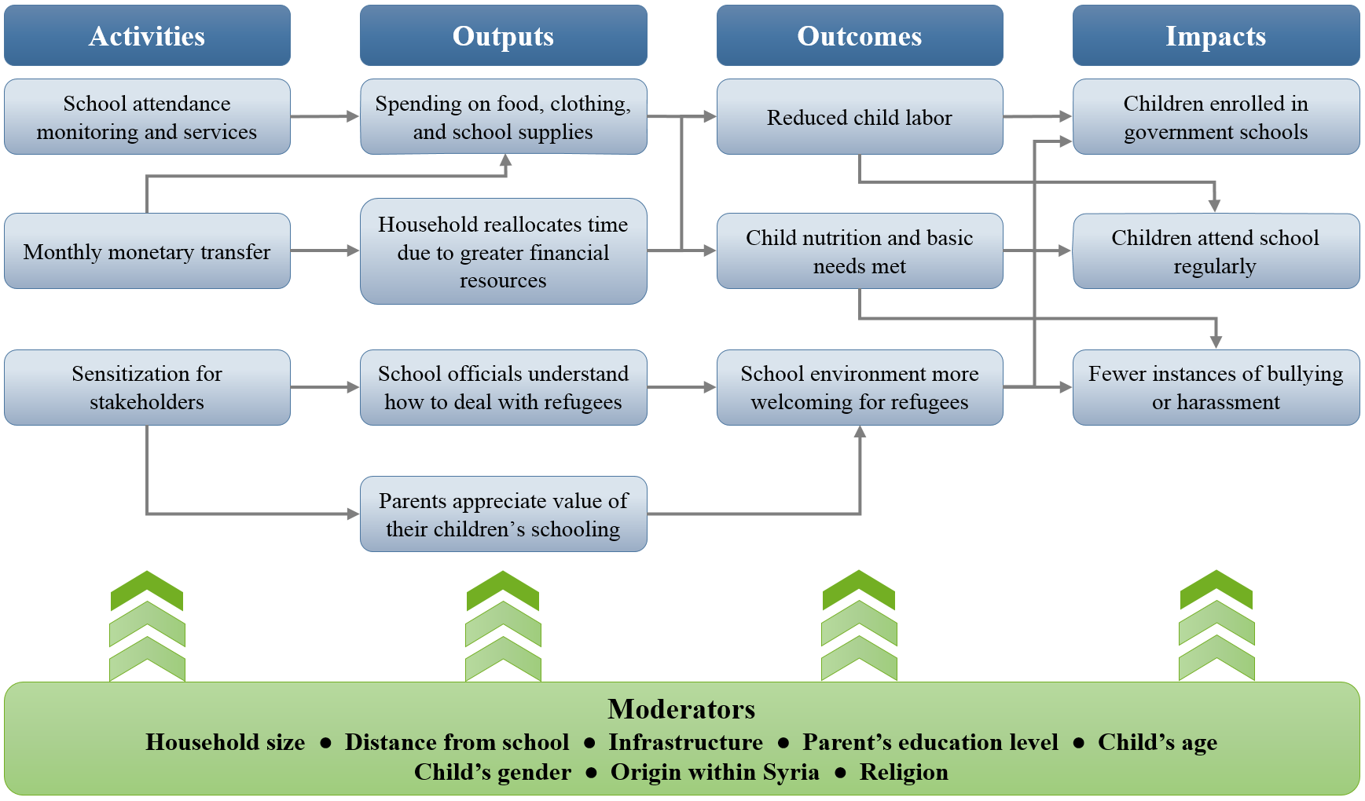

IV. Study Design
The impact evaluation of Lebanon’s education-focused cash transfer program uses a longitudinal, geographical regression discontinuity design (RDD). The study will compare the education-focused cash transfer recipient households from beneficiary governorates (specifically Akkar and Mt. Lebanon) with eligible households in neighboring governorates (North Lebanon and South Lebanon respectively) that will not begin receiving the transfers during the period of the study (at least one year).
The 74 Cadaster clusters in these governorates were selected for the study: 21 in Akkar, 22 in North Lebanon, 20 in Mt. Lebanon, and 11 in South Lebanon. Cadasters were selected for the study based on their location near the border separating treatment governorates from comparison governorates and for being close to at least one second shift school. In other words, Cadasters near the Akkar–North Lebanon border were selected for the study as treatment or comparison cadasters, depending on which governorate they are located in. Cadasters along the Mt. Lebanon–South Lebanon border were similarly selected. The impact evaluation tracks the education outcomes of children in 1,456 households, roughly 20 in each of the 74 cadasters included in our study sample. The next sub-section describes how these households were selected.
We have the GPS coordinates for each household in the study, enabling us to calculate their distance from the border with its paired governorate. Map 1 shows the geographic distribution of second shift schools and study households. Large circles denote the 2.5 kilometer radius around the second shift school, small circles denote each treatment household, and small triangles denote each comparison household. The majority of households live within a 2.5 kilometer radius from a second shift school and should, in principle, not be eligible to receive UNICEF and Caritas school transport services.
The study will calculate the average impact on households in the treatment governorates by comparing households that are close to the border that separates them into treatment and comparison conditions. A so-called difference-in-difference model exploiting the longitudinal data collected for these households will be used to capture changes over time. Geographical clustering of households within Cadasters will be accounted for in the analysis. Appendix B discusses the technical details of the estimation procedure in detail.
A major reason for choosing a nonexperimental RDD (rather than a randomized, controlled trial) is that a decision was made to roll out the pilot program at scale in the governorates of Akkar and Mt. Lebanon; thus, randomization could not occur within governorate and governorates were already selected for the pilot before starting the study. UNICEF is aware that the current design leaves open the possibility that observed differences between treatment and comparison households could result from an effect other than the cash transfers—for example, due to circumstances that occur in an early-entry governorate and do not occur in delayed-entry governorates (such as differences in local politics). For this reason, the study focuses on communities (cadasters) that are close to the border between treatment and comparison governorates in order to minimize geographic, economic, and political differences between catchment areas in treatment and comparison areas, as well as differences in the backgrounds of Syrians in the study sample. Education policies are determined centrally and do not differ across governorates. This means that differences between the two groups are likely to be minimal and (to a large extent) observable, and can be accounted for in the statistical analysis.
Map 1: Treatment and Comparison Areas
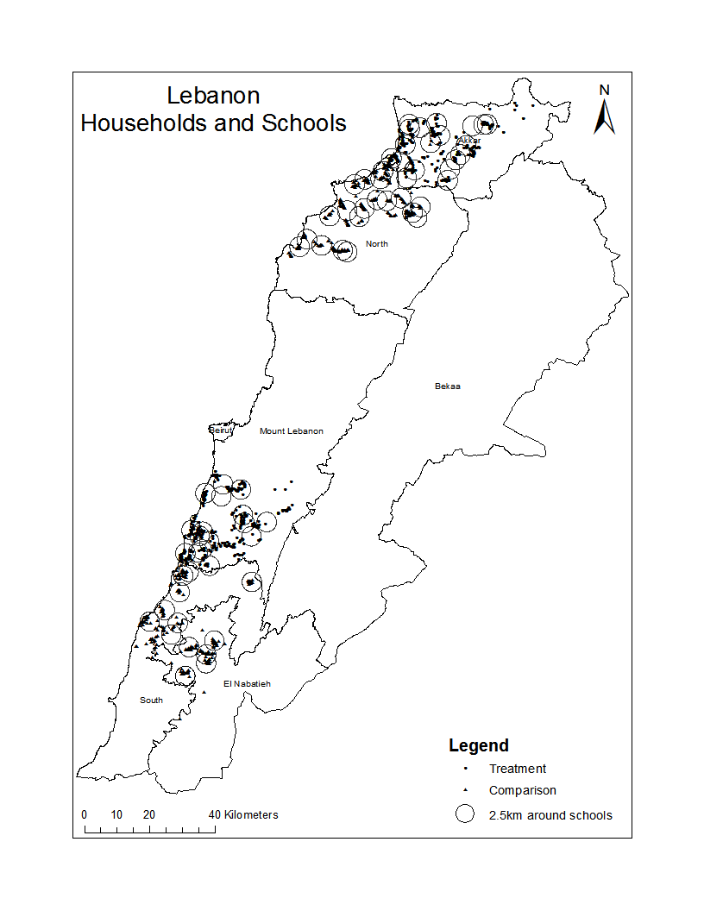

Sampling
Selected governorates have more beneficiary households than are needed for the sample, so a subset of households was identified and selected for the study. The steps for selecting the sample were as follows:
- UNICEF identified two treatment governorates to receive the program. The evaluation team then identified a neighboring governorate for each treatment governorate to serve as the comparison region.
- The evaluation team identified 74 cadasters located relatively near the border between the treatment and comparison governorates that are also near second shift schools. Cadasters located in the three largest cities of Lebanon (Beirut in Mt. Lebanon, Tripoli in North Lebanon, and Sidon in South Lebanon) were not considered to ensure that all selected Cadasters were located in similar peri-urban and rural locations.
- The cadaster (a small geographical unit) in which the school is located was considered the catchment area. The UNHCR provided a list of up to 100 randomly drawn eligible households in each cadaster. (Eligible households were displaced Syrian households with children aged 5 to 14 registered with the UNHCR.)
- If the list provided by the UNHCR contained fewer than 90 households, the evaluation team included neighboring cadasters as necessary in an attempt to obtain a list of at least 90 households in the vicinity of the school. For some schools, fewer than 90 households could be identified in the catchment area.
- Households were ranked in random order. Survey teams (discussed in more detail below) visited households in the order of this ranking until 20 households had been interviewed.

Power Analysis
It is vital to have a sample size that is sufficiently large to detect small but meaningful effects of the cash transfer program. For this reason, we conducted power calculations to determine the minimum detectable effect size for the evaluation. This study relies on a regression discontinuity design (RDD) that allows us to detect a program impact on school enrollment of 0.254 standardized mean difference effect size. This means that the study is well powered to detect effects of meaningful size if they exist. Due to the limited number of cadasters in each governorate, this study is unable to estimate impacts at the governorate level with reasonable precision (95 percent confidence), and can only estimate the impacts of the program as a whole.
The RDD is a less efficient estimator than simple random assignment by a factor of $D=\frac{1}{1-ρ^{2}}$, where $ρ$ is the correlation between treatment status and distance to the border. The correlation between treatment and distance to the border is 0.81, so the design effect is 2.94. This means that the study’s power is equivalent to that of a randomized controlled trial with a number of observations that is 34 percent of the number used for this study. Therefore, we can estimate the power of this study by calculating the power of a randomized controlled trial with 34 percent of this study’s observations in each cadaster cluster. There are 74 cadaster clusters in our sample: 40 treatment cadaster clusters and 34 comparison cadaster clusters. We expect data from 20 households in each cadaster cluster. We conservatively assume that there will be two transfer-eligible children per household, for a total of 40 children per cadaster cluster. Calculating the intra-cluster correlation for school enrollment in the baseline data provides a number of 0.12. We expect baseline covariates to explain 30 percent of variation at the individual level and 15 percent of variation at the cadaster cluster level.

V. Overview of Baseline Data Collection
UNICEF hired Statistics Lebanon (SL), a locally based research and data collection organization, to oversee and coordinate quantitative data collection via household questionnaires in the Mt. Lebanon, North Lebanon, Akkar, and South Lebanon governorates. UNICEF, SL, and AIR facilitated data collection training among SL data collectors during the first two weeks of August 2016. SL began collecting household data on August 19 in all treatment and comparison governorates.

Outcomes and Measures of Interest
The evaluation relies on a single household survey instrument to collect quantitative baseline data. The theory of change and research questions motivate the domains covered in the baseline data collection. These domains, which are displayed in Table 5.1, include the following: household demographics, living conditions, economic and poverty status, parent characteristics, and child characteristics. Indicators in these domains relate to control variables, moderating variables, or outcome variables. Control variables are those that would not likely change as a result of the program but might affect the outcome variable, such as household size, marital status, parents’ education level, and years displaced from Syria. Moderating variables might affect the program’s ability to affect outcomes, such as distance to the nearest school and access to other programs and services. Outcome variables are indicators that the program strives to affect as either intermediate or final goals, such as child enrollment and attendance in school, child labor, child health, and child food security.
Table 5.1. Topics in Survey Questionnaire
Household Survey
Roster
Health
Education — 5+ years old
Main economic activity — 5+ years old
Income
Household assets
Housing conditions
Household enterprises
Credit
Access to facilities and services
Self-assessed poverty and food security

Training and Piloting
Quantitative data collection training took place from August 1 to 18, and incorporated two pilots on August 5 and 11. UNICEF facilitated the first round of trainings, and the second round was collaboratively facilitated by SL and AIR. The facilitators and enumerators continuously revised the household questionnaire and their data collection strategy based on feedback and lessons learned during training and piloting.
Table 5.2. Training Timeline
 | Dates
First round of training | August 1–2
Questionnaire and manual revisions | August 3–4
First pilot | August 5
Second round of training | August 8–10
Second pilot | August 11
Questionnaire and manual revisions | August 12–18
During the first round of trainings, UNICEF facilitators led enumerators through a detailed walk-through of the original questionnaire in English. The purpose of the walk-through was to ensure that the enumerators understood each question and the corresponding response options. At the end of the training, the enumerators practiced administering the first version of the Arabic translation of the survey. One person was asked to administer the questionnaire, another played the role of the respondent, and the remaining enumerators were strictly instructed to observe and only share their notes at the end of the interview. This exercise was intended to familiarize the enumerators with the Arabic version of the instrument before the pilot.
The first pilot was implemented on August 5. AIR and SL met with the data collection team for two hours to go through the revised version of the questionnaire. The enumerators then began the pilot in a Beirut neighborhood largely occupied by Syrian refugees. In addition to piloting the questions, some enumerators conducted the interview using tablets. This was an opportunity to practice using the tablets, and it also allowed enumerators and programmers to improve the tablet survey program by assessing its performance during the pilot.
The second round of trainings incorporated lessons learned from the first pilot and emphasized the “dos and don’ts” of effective interviewing. During the training, the enumerators practiced administering the questionnaires on the tablet with the direct assistance of the tablet programmer.
The second pilot occurred on August 11 in the same urban neighborhood as the first pilot. However, the team interviewed different Syrian households that met the criterion of having one or more children between 5 and 14 years old. Compared to the first pilot, enumerators significantly improved the accuracy of the responses to the questionnaire. The data collection team used the second pilot as an opportunity to finalize survey questions, ensure that the items were not repetitive or vague, and provide individual enumerators with feedback on ways to improve their interviewing skills.

Data Collection
Data Collection Teams
SL oversaw data collection and cleaning in all governorates included in the study. SL assigned a principal supervisor to coordinate and supervise data collection across the five enumerator teams. Each team consisted of a team leader and four enumerators. One team was assigned to each of the four governorates, and the remaining team provided backup and spot-checked the questionnaires. The team leaders were responsible for contacting interviewees, assigning activities, and supervising enumerators. Data collection began on August 18 and ended on November 1.
Quality Control
SL took several steps to ensure quality data collection, including trainings, supervision, and review. The trainings ensured that enumerators understood the purpose of data collection, were familiar with the data-collection instrument, and were informed of their roles and responsibilities. Enumerators also practiced interviewing refugee families and were provided with constructive feedback.
Team leaders supervised and supported enumerators at each stage of data collection. SL also implemented multiple levels of quality review: enumerators reviewed their work to ensure that it was consistent and error-free before submitting it to the team leader, who reviewed the questionnaires at the end of each day. The SL headquarters randomly selected interviews for additional review.
Ethics for Data Collection
The evaluation team took great care to comply with the highest level of ethics and standards for working with human subjects as part of the study. The study design, instruments, and data-collection procedures passed AIR’s Institutional Review Board (IRB), which assesses a project’s compliance with the standards of conduct and protection of the rights of human research subjects. All AIR staff, sub-contractors, and consultants involved in the collection of data from human research participants (including children) must adhere strictly to the requirements of AIR’s IRB. The IRB pre-approved all research activities and protocols involving human subjects in this study, as well as the information security plan to protect the confidentiality of data from research participants. All participants were asked for their informed consent/assent to engage in activities specific to the research components of this project. Participants were asked to give their consent/assent in Arabic, worded at an appropriate level for their age and educational background.
AIR’s IRB follows the standards set forth by the American Evaluation Association Guidelines and the Joint Committee on Standards for Educational Evaluation. Three general principles define these standards: (a) evaluators will conduct evaluations legally and ethically, taking into account the welfare of those involved in the evaluation, as well as the general public; (b) evaluators will conduct evaluations in a competent and efficient fashion that will lead to reliable and accurate results; and (c) evaluators will design evaluations and report the results in a manner that is useful and appropriate to the intended audience. Clear guidelines exist regarding the expectations with which local data collectors must comply (e.g., how to document informed consent, how to store and restrict access to physical files and electronic data files, the treatment of identifiable information, and so on).
Data Collection Challenges
The nature of the study resulted in a significant number of data-collection challenges, further affirming the difficulty of collecting quality data in humanitarian settings. For example, the SL data-collection team received an uneven number of eligible cases in both treatment and comparison governorates. The team received less than 50 cases for some cadasters, which, compounded by low response rates, meant that the enumerators could not collect data for 20 households in each cadaster. UNICEF addressed this issue by requesting data on additional eligible households from the UNHCR. The data collectors also encountered issues related to the following:
- High mobility: Many families moved to other areas. To mitigate the potential for attrition, an extensive tracking module collecting contact information for each family was incorporated into the household questionnaire.
- Access: Enumerators called identified households (using phone numbers provided by the UNHCR) to make appointments for the interviews. Enumerators needed to call the majority of respondents multiple times before they successfully contacted them. Some families did not answer SL’s calls. In some cases, respondents lived in areas that were difficult to access.
- Location: The majority of respondents could not provide enumerators with their exact location during the initial phone call, which made it difficult for enumerators to find them. SL recorded respondents’ location using GPS technology. However, sometimes the enumerators collected data in areas where there was low GPS coverage or where the GPS reading was subjected to radio-disruption activities. This made it difficult for enumerators to collect accurate GPS readings, particularly in South Lebanon and Akkar governorates.
- Incorrect information: SL received outdated contact information for some families and could not get in touch with them. In other cases, when SL successfully contacted some families, the respondents stated that they had children during the phone call. However, when the enumerators visited those families, they discovered that the respondents did not have children.
Throughout the data collection process, SL maintained close communication with UNICEF and AIR.

VI. Sample Description
It is important to understand eligible beneficiaries’ initial conditions before receiving the transfer so that we can evaluate whether the program affected key outcomes, control for confounding factors, and understand how moderating factors might affect the transfer’s ability to produce effects. Here, we summarize the characteristics of potential transfer beneficiaries—that is, households in the treatment governorates—focusing on children between 5 and 14 years old, household demographics, housing conditions, economic well-being, and adults.
The primary goal of the program is to increase child enrollment and attendance in school and reduce harmful coping strategies such as child labor and early marriage. The program targets households with children aged between 5 and 14 years old and provides a different amount of money depending on the age of the children. Households registered with the program receive $20 per month per child aged five to nine and $65 per month per child aged ten to fourteen. We begin by describing the children who qualify for the cash transfer by the two age categories, focusing on child labor, education, and marriage indicators. We continue with a description of household demographics to understand the size and composition of the households, with respect to the age and gender of family members. Understanding household composition will help us to understand the amount of money these households will likely receive from the program, depending on the age and number of children they have.
We follow with a description of eligible beneficiaries’ housing conditions and economic well-being. Housing conditions, such as access to water, proper sanitation, and electricity, can affect a child’s health—a factor along the causal pathway to improving the child’s educational attainment. A household’s economic well-being also affects its food security and the need for children to generate income for the household. As depicted in the theory of change, these measures serve as both control and moderating factors that affect children’s educational attainment.
We conclude by describing the adults in the households. Adult factors, such as education level, employment status, and beliefs about education, are often highly correlated with their children’s educational attainment, so these measures can serve as both control and moderating variables in the model.

Children Aged Five to Nine Years Old
There are 1,149 children between the ages of five and nine in the beneficiary households, half of whom are female (49 percent). These children qualify for the transfer at the lower rate of US$20 per month. Almost half of the children in this age range can read (44 percent), and 67 percent attended school in the 2015–16 school year, with no substantive difference between boys and girls. Table 6.1 shows that 79.6 percent of children between the ages of five and nine who are in school attend a public school. Slightly over half of public school students attend second shift schools. For almost half of the children who did not attend school (41 percent), cost was the reason provided. Again, this was similar for boys and girls. This suggests that the cash transfer program has the potential to increase school participation rates in this age group substantively. Households bear a high cost for young children attending school, spending almost twice a person’s monthly income on a child’s education each year ($92.79). Small households spend more on education per person ($72.17) than large households ($53.75).
Children’s age was also given as a reason for not being in school, with some families reporting that their child was too young for school. Figure 6.1 shows enrollment by age for children aged five to nine. Five- and six-year-old children had the lowest enrollment rates, with five year olds enrolling at almost half the rate of seven, eight, or nine year olds. This is consistent with the idea that some parents felt their child was too young for school. Children typically spend about 20 minutes travelling to school, and this distance could be seen as too far for younger children. Figure 6.2 shows the distribution of time to travel to school for children aged five to nine. Almost half of the children take a fee based bus or minibus to school (47 percent), 27 percent take a non-fee bearing school bus, and 24 percent walk. Figure 6.3 shows the distribution of methods used by children in this age range to reach school.
Table 6.1. Enrollment by Age
Age | Private | Public - 1st Shift | Public - 2nd Shift | Free Private | Other
5-9 | 33 | 258 | 334 | 19 | 99
10-14 | 23 | 230 | 253 | 9 | 94
Total | 56 | 488 | 587 | 28 | 193

Figure 6.1. Enrollment by Age
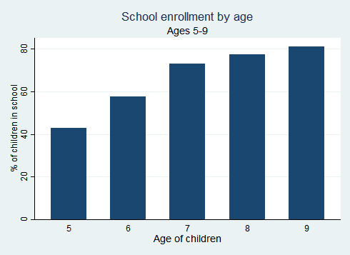

Figure 6.2. Distance From School
Figure 6.3. Mode of Travel to School, Ages 5-9 Years Old

Almost no child labor was reported for children in this age range (0.7%). It was reported that these children generally do not work because they are too young. Figure 6.4 shows that households considered children in this age range too young to work.
Figure 6.4. Reasons a Child Does Not Work
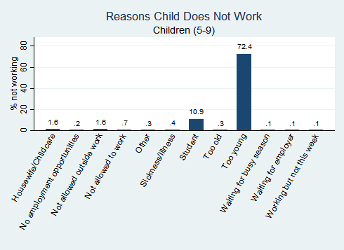
Most children aged five to nine years old have their basic material needs met. Almost all of the children in this age range have shoes (92 percent), and 80 percent of children have winter clothes (not surprisingly since UNICEF and UNHCR have other programs that provide resources for winter clothes). These estimates are consistent across gender and household size. The level of these indicators is quite high, which means that there is not a lot of room for the cash transfer to affect and improve on them. The mothers of all the children in this age range are still alive, as are almost all of the fathers (2.73 percent of children had a deceased father). A larger percentage of children have a father alive but missing from the house (7.58 percent).

Children Aged 10 to 14 Years Old
Older children are more likely not to attend school and to be working outside of the house for income. There are 948 children between the ages of 10 and 14 in beneficiary households in the sample, 46 percent of whom are female. These older children qualify for the transfer at the higher rate of US$65 per child. Seventy-seven percent of children in this age range are literate, which is approaching the adult literacy rate of beneficiary households in the sample. Literacy rates are roughly identical for boys and girls. However, girls aged 10 to 14 years old are 6 percentage points more likely to enroll in school than boys (70 percent versus 64 percent, respectively). School enrollment decreases with age, with 14 year olds enrolling at almost half the rate of 10 year olds (40 percent compared to 78 percent, respectively). Figure 6.5 shows enrollment by age for children aged 10 to 14 years old.
Cost was the primary reason for children in this age range not attending school (63 percent), suggesting that the cash transfer program could have a substantive impact on schooling outcomes. For children who are enrolled in school, households spend an average of $87.21 per child annually on educational expenses, which is roughly the same as for younger children. Older children typically spend about 20 minutes travelling to school—the same amount of time as children aged five to nine years old. Approximately half take the bus or minibus (43 percent), 28 percent take a school bus, and 27 percent walk. Figure 6.6 shows the distribution of methods used by children in this age range to travel to school.
Unlike the children aged five to nine, there are children in the 10–14 age group who work outside the home. On average, 6 percent of children in this age range worked outside of the house during the week prior to the baseline survey. Child labor participation increases dramatically as they get older. Figure 6.7 shows that almost 14 percent of 14-year-old children work, compared to 7 percent of 13-year-old children (and 19 percent of 16-year-old children). Children aged 10 to 14 who work spend an average of 20 hours per week outside the home for income.
Although child marriage is believed to be a coping strategy for dealing with poverty, we do not find the prevalence of marriage for children in this age range at baseline with less than 0.1 percent (10 children) married.
Figure 6.5. Enrollment by Age (10–14 years old)

Figure 6.6. Method of Traveling to School for Children Aged 10–14
Figure 6.7. Child Labor
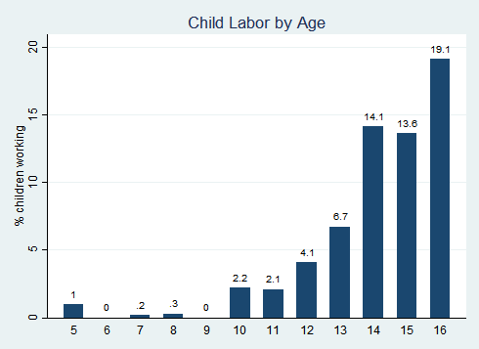
Figure 6.8. Time Spent Working

Most older children have the items necessary to meet their basic material needs. Almost all of the children have shoes (94 percent), and 82 percent have winter clothes. Both measures are consistent across gender and household size. This means that there is little room for improvement, so cash might not be able to affect children’s material needs. Orphans are more common among older children: 1.1 percent of older children have a deceased mother and 4.7 percent have a deceased father. This may contribute to the increased likelihood that older children work.

Demographics
The average eligible beneficiary household in the sample contains six people, including at least two children between 5 and 14 years old (cash transfer recipient age) and two adults. We therefore expect the average eligible beneficiary household to receive multiple transfers each month—including both smaller and larger transfers—because they have more than one child who qualifies for the program. The beneficiary sample is primarily made up of working-age adults and children, with less than 1 percent aged 65 or older. The sample of eligible beneficiaries is well balanced by gender, with roughly the same number of males and females in each age group. Table 6.2 shows the breakdown of the eligible beneficiary sample by age and gender. Most of the children are aged between 5 and 14, which in unsurprising given that the program targets households with at least one child in this age range. Figure 6.9 depicts the distribution of the beneficiary sample by age and gender. The bi-modal distribution has peaks for children aged 6 to 15 years old and adults aged 30 to 45 years old. This demographic distribution is the result of the program’s targeting—children aged 5 to 14 years old—which also makes it likely that their parents fall in the 30–45 age range. The total sample of cash transfer recipients includes 4,998 people. Almost 42 percent of the sampled individuals in treatment areas are children aged 5 to 14 years old.
Table 6.2. Household Demographics
Age | Male | Female | Children Per Household | Total
0 to 4 | 323 | 350 | 0.84 | 673
5-9 | 588 | 561 | 1.44 | 1,149
10-14 | 514 | 434 | 1.19 | 948
15-64 | 1,087 | 1,110 | 2.75 | 2,197
65+ | 10 | 21 | 0.04 | 31
Figure 6.9. Age Distribution
The median eligible beneficiary household has six people, with most households containing five to nine people. Throughout this study, we investigate differences by household size, breaking the sample into small households (six members and under) and large households (more than six members). With respect to demographics, we found that small households are more likely to be single-headed than larger households (10.3 percent versus 4.4 percent, respectively). Household size could correlate with economic well-being, housing conditions, and children’s educational attainment, depending on how many adults in the household can earn an income and how many dependent children require resources provided by other family members. Figure 6.10 depicts the distribution of households by size.
Figure 6.10. Household Size
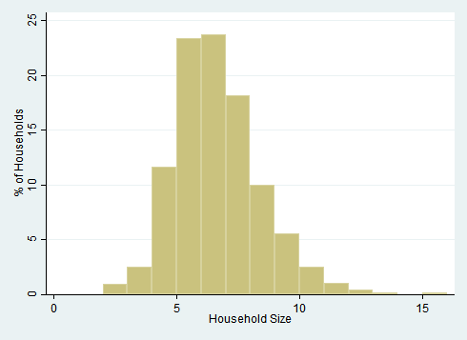
It is important to understand how long these households have been displaced and living in Lebanon in order to get a sense of how familiar they might be with their current context. The average household left Syria 4.71 years ago, suggesting that households stayed in Syria for about one year after fighting broke out in April 2011. Although we cannot say how long they have lived in their current location, it seems as though households have lived in Lebanon for a sufficient amount of time to understand important processes such as school enrollment or searching for jobs. Figure 6.11 shows the distribution of time displaced from Syria for the households in the sample.
Figure 6.11. Length of Displacement
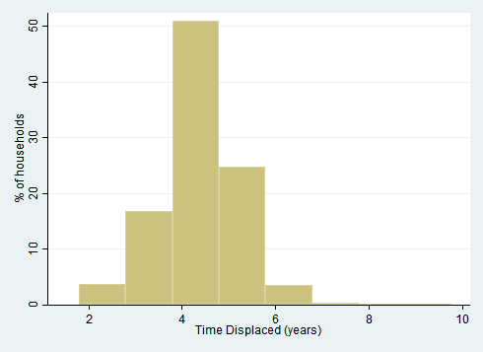

Housing
The eligible beneficiary households included in the sample generally live in housing with access to basic utilities, but the areas are crowded and lack access to a good water source. Over half of the households do not have access to a safe water source, and many have to purchase bottled water. This situation is problematic because unsafe drinking water can lead to health problems and can prevent children from attending school. The money spent on bottled water also adds to a household’s economic burden. Lack of access to a water source in the household also means that less than half of households have a flush toilet, with the rest using a latrine. Figure 6.12 shows the distribution of eligible beneficiary households by type of water source. Most households have access to a legal source of electricity (84 percent). Enumerators report that a maximum of 11 percent of eligible beneficiaries (1) live in poor conditions, (2) live with physical dangers, (3) live in dangerous conditions, or (4) live in a house in need of urgent repairs. Living in safe and well-built housing can help children focus on their schooling. However, it is important to note that the enumerators recorded these housing measures subjectively, which means that they may not reflect the views of the actual beneficiary.
Figure 6.12. Water Sources
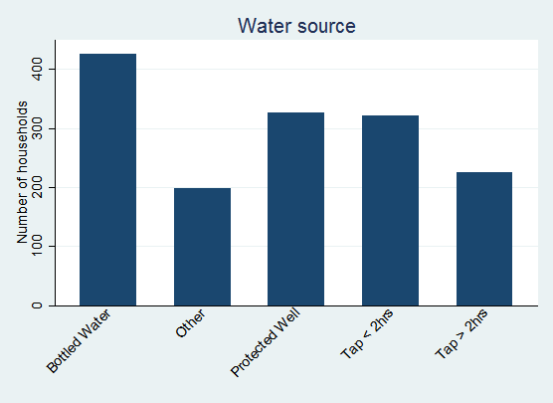

Economic Well-Being
Eligible beneficiaries survive on low levels of income (most of which comes from cash earnings and UN cash aid), take on debt to meet their needs, and face frequent food insecurity. Daily income per capita ($1.71) is less than half of the Lebanese poverty line, which stands at $3.84 per person per day. Such low incomes suggest that eligible beneficiaries do not make enough to meet their basic needs. For the 89 percent of households renting their home, over half of their income (54 percent) goes toward rent. This helps to explain why 57 percent of children are out of school due to cost. We merged UN data about other cash transfer programs to determine how many transfers each household receives in addition to this program’s cash transfer. Almost all households (86 percent) receive at least one other type of humanitarian cash transfer, as shown in Figure 6.13 (most households receive only one other transfer).
Figure 6.13. Number of Humanitarian Cash Assistance Programs
Households rely on debt as an important way of meeting their basic needs, supplementing their income by taking on debt equal to roughly half of their total income. The average household takes on approximately $185 of debt per month—52 percent of its monthly income. Households cannot meet their basic needs from income alone if they need to take on debt. Households may avoid optional expenditures such as school fees instead of taking on debt. Small households have $3 more monthly income per capita ($61 versus $58) but $13 more monthly debt per capita ($38 versus $25) than large households. Small households may therefore be in greater need of cash support for their children’s education.
Households faced frequent food insecurity during the week preceding the baseline survey. Slightly more than half of households (52 percent) reported not having enough food in the seven days prior to the survey. Children with poor diets are likely to have poor school attendance. However, children suffer less food insecurity than adults. Only 13 percent of eligible beneficiaries reported that a child skipped a meal, even though 39 percent reported that someone had skipped a meal. This suggests that adults assume the burden of food insecurity by skipping meals themselves.

Adults
There are 2,011 adult members of eligible beneficiary households, approximately half of whom are female (52 percent). The average adult is 35 years old and completed only a few years of education. The literacy rate is 87 percent for men and 78 percent for women. Over half of the adults (53 percent) have not completed middle school. There is no substantive difference between men and women’s educational attainment.
Labor-force participation is low among adults in eligible beneficiary households, probably reflecting the constraints to adult engagement in economic activities described earlier in this report. Only 27 percent of adults worked during the week prior to the baseline survey. Figure 6.14 shows that adults work across industries, although construction is the most common sector.
Figure 6.14. Employment Sectors
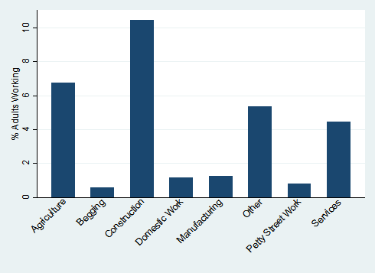
Although rates of participation in economic activities are low, most adults are physically able to work in some capacity, with 79 percent reporting good health. Roughly half reported that they can walk (52 percent) or sweep (47 percent) easily. Figure 6.15 shows ease with which adults in eligible beneficiary households can walk and sweep as a proxy for their physical capability.
Figure 6.15. Physical Capabilities
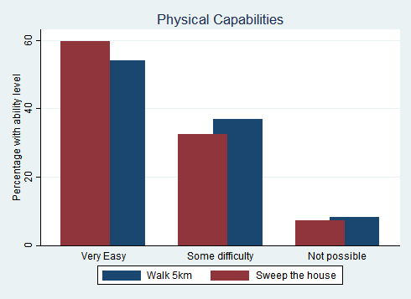

VII. Comparison to National Statistics
We compare eligible beneficiaries in our sample to a nationally representative sample from the VASyR (2016) to see how the target population of the cash transfer program differs from the general displaced Syrian population living in Lebanon. The eligible beneficiary households in the study live in Akkar and Mt. Lebanon governorates and in cadasters with second-shift schools located nearby. The sample of displaced Syrian households in the VASyR live all over Lebanon. This study also targets families with school-aged children, creating further differences between our sample and the nationally representative sample. In this section, we compare the statistics presented in the VASyR with those from our study. (We were unable to test for statistical differences between the two studies because we do not have access to the VASyR data, only the report.)
Overall, the elgible beneficiaries in this study are similar to the larger population of Syrian refugees in the VASyR. For instance, we found that the households in this study have the same demographic makeup as the larger refugee population. Housing quality for the two samples was different, but neither sample was clearly better than the other. However, we found meaningful differences in economic well-being: Targeted eligible beneficiaries in our sample earn more at the household level and the per-capita level than those in the VASyR sample. We found similar differences in children’s education: Cash transfer recipients’ children attend school more frequently than the overall population of Syrian refugee children prior to the implementation of the pilot program. This difference could represent a selection effect—for instance, households that attach more value to education may purposefully locate closer to a public primary school and the study focused on households located near second shift schools.

Demographics
The ratio of women to men is more balanced in our sample than the VASyR sample. We found 0.98 females for every male in our sample, compared to 1.30 females per male in the VASyR sample. However, we found that our sample had a similar dependency ratio: There are 1.9 dependents per working-age adult in our sample, compared to 1.5 dependents per working-age adult in the overall population of refugees (where dependents are defined as those under 18 years old and those aged 60 or older). Adults in our sample are similarly literate to the total refugee population: 83 percent, compared to 82 percent of adults in the VASyR sample.

Housing
Housing for elgible beneficiaries of other UN cash transfers in Akkar and Mt. Lebanon is similarly expensive to housing for other Syrian refugees. We found that elgibile beneficiary households pay $168 for rent each month, compared to $164 per month for VASyR households. Our sample lives in housing that is better in some ways and worse in other ways than the larger Syrian population’s housing. For example, 6 percent of cash transfer eligible beneficiaries have access to tap water for more than two hours per day, compared to 22 percent of households in the VASyR sample. However, the cash transfer eligible beneficiaries in the study have better toilet facilities: 99 percent have a flush toilet or latrine, compared to only 80 percent of all Syrian refugees.

Economic Well-Being
Eligible beneficiaries in our sample earn more income than the overall refugee population. The average household’s monthly income is $51 per capita in our sample, compared to $38 per capita in the 2016 VASyR sample.

Child Outcomes
Children in eligible beneficiary households in our sample are more likely to attend school: 69 percent of children aged 5 to 14 attend school, compared to 52 percent in the VASyR sample.
Table 7.1. Summary of Comparisons Between the Cash Transfer Study Sample and the VASyR Sample
Demographics | Study Sample | VASyR Sample
Household size | 6.27 | 5.30
Dependency ratio | 1.9 | 1.5
Adult literacy rate (%) | 83 | 82
Housing
Monthly rent (USD) | 168 | 164
Tap water runs > 2 hours/day (%) | 6 | 22
Access to flush toilet/latrine (%) | 99 | 80
Economic Well-Being
Monthly income per capita (USD) | 51 | 38
Child Outcomes
School attendance (5–14 years old) | 69 | 52
1+ child under 18 years old in household working (%) | 9.0 | 7.5

VIII. Baseline Equivalence
The primary purpose of the baseline data collection is to measure the starting point for everyone in the sample and check that the treatment and comparison conditions are balanced before the start of the intervention. This section reports the mean differences at baseline for primary outcomes and moderating variables between the treatment group and the comparison group on the household survey. In theory, using the same targeting process in similar cadasters and governorates should lead to a balance in terms of outcome and control indicators between the two conditions, but this may not always happen. For this reason, we measured each group at baseline and tested for differences to determine whether the identification process led to a balanced sample. We only report indicators that are statistically significantly different at baseline.
Applying the RDD estimation procedure outlined in Appendix B, we found that the treatment and comparison groups were similar for almost all outcome and control variables. This suggests that the comparison group is a suitable counterfactual for the treatment group. Most importantly, we found equivalence for the primary outcomes of the study, including child education and child labor indicators. We tested over 90 indicators and found only three statistically significant differences between the two groups. This number of differences is very low, especially considering that we expected to find a certain number of significant differences due to the number of tests that we ran. Specifically, we expected to find one spurious result for every 20 indicators tested, since we set the alpha level to 0.05 for significance. The number of statistically significant differences we found therefore falls well within the range expected, given the number of indicators.
We evaluated baseline equivalence using the RDD methodology to test whether households in pilot governorates (Akkar and Mt. Lebanon) were statistically different from comparison households. In our (ordinary least squares regressions, we included a regional dummy (taking the value 1 for North Lebanon and Akkar and 0 otherwise) to account for stratification and we controlled for distance to the border of the matched-pair governorates for each household. We clustered at the cadaster level to account for geographic correlation of errors. Only statistically significant differences are presented below. All results, including nonsignificant findings, may be found in Appendix A.
The tables below present the mean and sample size for the comparison and treatment groups for each indicator. They then present the difference between the two means, the standard error of the mean difference, and the p-value resulting from the mean difference test. The last column is the standardized mean difference between the treatment and comparison groups, which provides the magnitude of the mean difference between groups. The three indicators below show that comparison households pay slightly more in rent per month and earned a little more money per capita in the seven days prior to the baseline survey, and that adults in comparison households skipped fewer meals than those in the treatment group. Although these results might lead one to believe that the comparison group is better off than the treatment group, one should remember that we tested and found equivalence between the treatment and comparison groups for dozens of indicators, including many focused on economic well-being and food security, such as income per capita, debt per capita, perceptions of enough food, housing conditions, and so on.
Table 8.1. Housing Differences
 | Control |  | Treatment |  | Balance Test
Variable | Mean | N1 | Mean | N2 | Diff | SE | p-value | ES
Rent (USD monthly) | 180.91 | 621 | 167.54 | 794 | -48.83 | 16.31 | 0.01 | -0.49
Notes: Standard errors are robust to heteroscedasticity and clustered at the “cadaster cluster” level.
Table 8.2. Differences in Economic Well-Being
 | Control |  | Treatment |  | Balance Test
Variable | Mean | N1 | Mean | N2 | Diff | SE | p-value | ES
Household cash earnings per capita USD  (past 7 days) | 9.79 | 657 | 8.27 | 799 | -4.05 | 1.76 | 0.02 | -0.29
Skipped meal (adults) | 0.12 | 656 | 0.39 | 799 | 0.19 | 0.06 | 0.00 | 0.42
Notes: Standard errors are robust to heteroscedasticity and clustered at the “cadaster cluster” level.

IX. Conclusion
The primary purpose of this baseline report is to describe the beneficiaries in the study sample prior to receiving the program, and to present the equivalence of the treatment and comparison groups. Describing the elgible beneficiary sample at baseline helps stakeholders to assess if they have accurately targeted the type of people they want to benefit from the program. It also helps stakeholders to understand where beneficiaries need more assistance and how best to design a program that meets beneficiary needs. The baseline survey revealed that the program targets households with an average of at least two children in the target age range of 5 to 14 years old, which means that households qualify for multiple transfers. Our baseline report focuses on two domains of outcomes of interest for children—education and labor—which we investigate by the program’s age ranges of five to nine years old and 10 to 14 years old.
We found that, on average, 66 percent of children in both age ranges enrolled in school in the previous school year, with the lowest enrollment rates among the youngest children (five to six years old) and the oldest children (13 to 14 years old). Parents might feel that the youngest children are too young to enroll in school, which means that the program may not have an impact on children of this age. However, the program could have a big impact on older children in the sample, whose enrollment rates averaged under 50 percent. Households reported that cost was one the biggest reasons for children not enrolling in school, and the cash transfer could help to alleviate this barrier. Almost 50 percent of the children take a bus or minibus to school—a large cost for attending school in addition to the common costs of school uniforms, books, and pencils. We also found that child labor rates increase with age: only 7 percent of 13 year olds work, compared to 14 percent of 14 year olds. The cash transfer could help to replace the income from child labor, freeing up time for older children to attend school. Child labor rates are very low (under 1 percent) for younger children, so there is little room for the program to improve on this indicator. We would not expect reduced child labor to be a pathway for the program to increase school enrollment for younger children.
In addition to child outcomes, we also investigated household indicators that the program could affect (leading to improved child outcomes), such as food security and economic well-being. We found that households in beneficiary governorates earn a per-capita income that is less than half of the Lebanese poverty line, demonstrating that they are very poor and vulnerable households. Almost all of them rent their housing and spend half of their household income on rent. Not surprisingly, their financial situation negatively affects their food security, with half of the households reporting that they do not have enough food and 40 percent reporting that they skip meals. The cash transfer is likely to have an impact on food security because food is often one of the first purchases food-insecure households make when their income increases.

Baseline Equivalence
In addition to describing the eligible beneficiary sample, we also investigated baseline equivalence between treatment and control groups. We care about baseline equivalence purely as a technical aspect of the study design because it helps to assess the internal validity of the study—that is, the ability of the study to attribute causality to the program when differences are observed between the treatment group and the comparison group at the end of the study. It also tells us what factors we need to control for in our later analysis of impacts. We found that the comparison group serves as a good counterfactual because it is very similar to the treatment group across domains of interest to the program, both in terms of outcome indicators and demographic characteristics associated with the outcomes of interest. The study used a geographic regression discontinuity design, where households in the treatment and comparison conditions are compared based on their similar distance from the border separating them (i.e., the border between treatment and comparison governorates). We found that households look very similar across all domains of interest, after controlling for their distance from the border. Communities were selected for the study in part based on their relative closeness to the border separating them from their matched-pair governorate that is in the opposite condition to them. This decision was underpinned by an assumption that the border is arbitrary, and that households near it on either side therefore experience the same economic conditions, weather, policies, culture, and so on. Evidence from the baseline data suggests that this assumption holds true, as households that are similar distances from the border are (on average) the same for all indicators. This suggests that the study design has produced a strong counterfactual that will enable us to attribute differences between treatment and comparison groups to the cash transfer program (and not other factors) at the end of the study.

Limitations
Although the baseline data demonstrate equivalence between treatment and comparison groups prior to the program beginning, there are still a number of limitations that the design cannot mitigate. First, the potential for spillover effects or contamination of the comparison group is one limitation that results directly from the study design. The treatment and comparison cadasters were selected specifically for their relative proximity to the border that separates them. This selection process means that treatment and comparison communities are fairly close to each other, which increases the risk that comparison households could benefit from the program by relocating, sending their children to live with family/friends in treatment communities, or gaming the system to appear as if they live in a treatment area in order to receive the program. If comparison households benefit from the program, the study will likely underestimate the impact of the program because the difference between the treatment and comparison group will be smaller than if there was no contamination of the program.
Second, the design does not allow us to estimate the long-term effects of the program. The evaluation will collect data soon after the program starts (as a rapid follow-up) in order to determine the short-term effects of the program on enrollment and child labor. The program will only work if households spend the cash transfer, but households might take some time to change their spending behaviors and adjust to their increased income, especially because they may not believe at first that the transfer will occur regularly as promised. The rapid follow-up evaluation may therefore take place too soon to capture the full effects and potential of the cash transfer program. Ideally, the evaluation will continue for at least a year to assess the longer term effects of the program on outcomes of interest.
Third, there has been a change in the bussing service provided by UNICEF to children in the treatment governorates that may affect the study. UNICEF used to provide free bussing to children who live far from schools, but they have discontinued this service only in the treatment governorates. Many children use some form of transportation to get to school, so this change in service means that children in the treatment governorates may face an additional cost to reach school than those in the comparison governorates. The evaluation team will try to address this concern by estimating program effects only for children who live close to school, as well as the entire sample, to see if there are differences in program impacts.

Timeline for Next Steps
UNICEF contracted AIR for the baseline and rapid follow-up study. Statistics Lebanon collected baseline data on many domains of interest at the end of 2016, which led to this report. UNICEF and WFP started to make cash payments soon after baseline data collection, just after the households started to sign up for school enrollment. Statistics Lebanon will collect a round of rapid follow-up data in February and March 2017 to specifically investigate child enrollment for the 2016–17 school year and child labor. AIR will analyze the data and submit a draft report in April 2017 that estimates the short-term effects of the program on education and labor. Ideally, UNICEF will continue the evaluation for at least 12 months to measure the impact of the program after a full year of implementation, and to investigate the many domains measured at baseline such as food security, household income, and debt, as well as education and child labor.

X. References

Berry, C. (2009). A framework for assessing the effectiveness of the delivery of education aid in fragile states. Journal of education for international development, 4(1), 1-12.

Biton, Y., & Salomon, G. (2006). Peace in the eyes of Israeli and Palestinian youths: Effects of collective narratives and peace education program. Journal of Peace Research, 43(2), 167-180.

Burde, D., Guven, O., Kelcey, J., Lahmann, H., & Al-Abbadi, K. (2015). What works to promote children’s educational access, quality of learning, and wellbeing in crisis-affected contexts. Interagency Network for Education in Emergencies and United Kingdom Department for International Development.

Corlazzoli, V., & White, J. (2013). Measuring the un-measurable: Solutions to measurement challenges in fragile and conflict-affected environments. Search for Common Ground/UK Department for International Development, 15.

Gaarder, M. (2015) Impact Evaluations in Fragile and Conflict Settings - what can we learn? World Bank.

Gilligan, M., Mvukiyehe, E., & Samii, C. (2010). Reintegrating ex-rebels into civilian life: Evidence from a quasi-experiment in Burundi. Unpublished paper.

Government of Lebanon and the United Nations (2014). Lebanon Crisis Response Plan 2015-2016.

Missing Out: Refugee Education in Crisis. (2016). UNHCR. Available: http://uis.unesco.org/sites/default/files/documents/missing-out-refugee-education-in-crisis_unhcr_2016-en.pdf.

OECD Development Assistance Committee. (2012). Evaluating Peacebuilding Activities in Settings of Conflict and Fragility—Improving Learning for Results. Paris: OECD DAC. Available at http://www. oecd-‐ilibrary. org/development/evaluating-‐donor-‐engagement-‐in-‐situations-‐of-‐conflict-‐and-‐fragility_9789264106802-‐en, last accessed November, 15(2012), 2008.

Paluck, E. L. (2010). Is it better not to talk? Group polarization, extended contact, and perspective taking in eastern Democratic Republic of Congo. Personality and Social Psychology Bulletin.

Puri, J., Aladysheva, A., Iversen, V., Ghorpade, Y., & Brück, T. (2015). What methods may be used in impact evaluations of humanitarian assistance? (Institute for the Study of Labor [IZA] Discussion Paper No. 8755). Bonn, Germany: Author. Retrieved from http://ftp.iza.org/dp8755.pdf

UNHCR Lebanon. (2016). Back to School. Available: http://data.unhcr.org/syrianrefugees/download.php?id=11317. Accessed March 2017.

Zakharia, Z., & Bartlett, L. (2014). Literacy education in conflict and crisis-affected contexts. Research report. Washington DC: USAID.

Appendix A. Baseline Equivalence Test by Domain
Table A.1. Household Demographic Characteristics
 | Control |  | Treatment |  | Balance Test
Variable | Mean | N1 | Mean | N2 | Diff | SE | p-value | ES
Household size | 6.05 | 657 | 6.27 | 799 | 0.08 | 0.20 | 0.69 | 0.05
Percent elderly (65+) | 0.01 | 3,969 | 0.01 | 4,998 | 0.00 | 0.00 | 0.44 | 0.03
Children (0–14) per household | 3.36 | 657 | 3.47 | 799 | 0.12 | 0.16 | 0.45 | 0.08
Young children (5–9) per household | 1.44 | 657 | 1.44 | 799 | 0.05 | 0.09 | 0.55 | 0.06
Older children (10–14) per household | 1.05 | 657 | 1.19 | 799 | 0.11 | 0.13 | 0.38 | 0.11
Large household | 0.34 | 657 | 0.41 | 799 | 0.08 | 0.05 | 0.10 | 0.16
Time displaced (years) | 4.70 | 655 | 4.68 | 798 | 0.45 | 0.51 | 0.38 | 0.10
Distance to border (km) | 18.89 | 657 | 11.32 | 799 | 6.11 | 3.94 | 0.13 | 0.53
Single parent household | 0.09 | 626 | 0.07 | 745 | 0.00 | 0.03 | 1.00 | 0.00
Child (0–17) with mother deceased | 0.01 | 2,405 | 0.01 | 3,005 | 0.00 | 0.01 | 0.47 | 0.06
Child (0–17) with father deceased | 0.03 | 2,374 | 0.04 | 2,992 | 0.00 | 0.01 | 0.73 | -0.03
Notes: Standard errors are robust to heteroscedasticity and clustered at the cadaster level.

Table A.2. Housing
 | Control |  | Treatment |  | Balance Test
Variable | Mean | N1 | Mean | N2 | Diff | SE | p-value | ES
Dwell crowded location | 0.46 | 657 | 0.32 | 799 | -0.05 | 0.08 | 0.51 | -0.11
Dwell poor conditions | 0.11 | 657 | 0.11 | 799 | -0.07 | 0.07 | 0.32 | -0.23
Dwell physical dangers | 0.04 | 657 | 0.04 | 799 | -0.04 | 0.03 | 0.22 | -0.19
Dwell dangerous conditions | 0.03 | 657 | 0.06 | 799 | 0.04 | 0.02 | 0.14 | 0.18
Dwell urgent repairs | 0.05 | 657 | 0.12 | 799 | 0.03 | 0.04 | 0.50 | 0.09
Legal/electric energy source | 0.83 | 655 | 0.93 | 797 | 0.06 | 0.06 | 0.37 | 0.17
Number of rooms | 2.46 | 657 | 2.47 | 799 | -0.19 | 0.19 | 0.31 | -0.17
Rooms (large household) | 2.60 | 226 | 2.49 | 325 | -0.18 | 0.26 | 0.50 | -0.15
Rooms (small household) | 2.39 | 431 | 2.46 | 474 | -0.22 | 0.18 | 0.22 | -0.20
Access to pumped water | 0.40 | 657 | 0.37 | 799 | -0.05 | 0.08 | 0.53 | -0.10
Access to toilet/latrine | 1.00 | 657 | 0.99 | 799 | 0.01 | 0.01 | 0.13 | 0.15
Rent (USD monthly) | 180.95 | 621 | 167.54 | 794 | 48.83 | 16.31 | 0.00 | 0.49
Rent $ (large household) | 180.91 | 218 | 166.75 | 322 | 59.19 | 22.99 | 0.01 | 0.56
Rent $ (small household) | 180.97 | 403 | 168.08 | 472 | -42.38 | 14.85 | 0.01 | 0.44
Notes: Standard errors are robust to heteroscedasticity and clustered at the cadaster level.

Table A.3. Economic Well-Being
 | Control |  | Treatment |  | Balance Test
Variable | Mean | N1 | Mean | N2 | Diff | SE | p-value | ES
Household cash earnings per capita USD (past 7 days) | 9.79 | 657 | 8.27 | 799 | -4.05 | 1.76 | 0.02 | 0.29
Household in-kind earnings per capita USD (past 7 days) | 0.52 | 657 | 1.71 | 799 | 0.57 | 0.52 | 0.27 | 0.12
Total income USD (past 30 days) | 335.74 | 657 | 310.33 | 799 | 36.75 | 37.64 | 0.33 | 0.14
Income $ (large household) | 440.13 | 226 | 357.02 | 325 | 11.90 | 50.74 | 0.82 | 0.04
Income $ (small household) | 281.00 | 431 | 278.32 | 474 | 66.91 | 32.86 | 0.05 | 0.29
Total income PC USD (past 30 days) | 55.72 | 657 | 51.38 | 799 | -6.86 | 5.59 | 0.22 | 0.16
Income PC $ (large household) | 56.30 | 226 | 45.26 | 325 | -0.38 | 6.37 | 0.95 | 0.01
Income PC $ (small household) | 55.41 | 431 | 55.58 | 474 | 10.18 | 6.21 | 0.11 | 0.22
Total debt PC USD (past 30 days) | 23.74 | 657 | 26.80 | 799 | -0.97 | 4.70 | 0.84 | 0.02
Debt PC $ (large household) | 15.44 | 226 | 19.96 | 325 | -0.55 | 4.45 | 0.90 | 0.02
Debt PC $ (small household) | 28.09 | 431 | 31.49 | 474 | 0.29 | 5.67 | 0.96 | 0.01
Total debt USD | 179.42 | 657 | 284.45 | 799 | 93.49 | 46.70 | 0.05 | 0.23
Total debt per capita USD | 32.10 | 657 | 49.27 | 799 | 18.51 | 9.21 | 0.05 | 0.26
Not enough food | 0.32 | 656 | 0.52 | 799 | 0.09 | 0.08 | 0.24 | 0.18
Skipped meal | 0.12 | 656 | 0.39 | 799 | 0.19 | 0.06 | 0.00 | 0.42
Adult spent day without food | 0.03 | 656 | 0.10 | 799 | 0.01 | 0.03 | 0.77 | 0.04
Children skipped meal | 0.02 | 656 | 0.13 | 799 | 0.02 | 0.03 | 0.53 | 0.07
Any assistance | 0.98 | 654 | 0.99 | 739 | -0.01 | 0.02 | 0.71 | 0.05
MPCA/LCC assistance | 0.36 | 654 | 0.39 | 739 | -0.02 | 0.07 | 0.82 | 0.03
WFP assistance | 0.92 | 654 | 0.91 | 739 | -0.01 | 0.03 | 0.63 | 0.05
UNICEF winter | 0.11 | 654 | 0.17 | 739 | 0.03 | 0.10 | 0.77 | 0.09
UNHCR winter ($147) | 0.56 | 654 | 0.61 | 739 | -0.00 | 0.06 | 0.95 | 0.01
UNHCR winter ($75) | 0.17 | 654 | 0.24 | 739 | 0.09 | 0.05 | 0.10 | 0.22
Notes: Standard errors are robust to heteroscedasticity and clustered at the cadaster level.

Table A.4. Adults' Characteristics (Aged 17+)
 | Control |  | Treatment |  | Balance Test
Variable | Mean | N1 | Mean | N2 | Diff | SE | p-value | ES
Female | 0.51 | 1,763 | 0.51 | 2,234 | 0.01 | 0.02 | 0.66 | 0.02
Age | 32.82 | 1,763 | 33.12 | 2,228 | 0.60 | 0.52 | 0.25 | 0.05
Married | 0.70 | 1,747 | 0.69 | 2,196 | 0.01 | 0.03 | 0.60 | 0.03
Attended middle school | 0.46 | 1,514 | 0.45 | 1,859 | 0.08 | 0.05 | 0.15 | 0.16
Employed (last 7 days) | 0.25 | 1,762 | 0.25 | 1,968 | 0.05 | 0.05 | 0.23 | 0.13
Hours working (last 7 days) | 35.50 | 429 | 28.66 | 485 | 5.74 | 3.02 | 0.06 | 0.31
Household head: High skill job in Syria | 0.10 | 434 | 0.15 | 550 | 0.09 | 0.05 | 0.08 | 0.27
Good health | 0.81 | 1,757 | 0.63 | 2,214 | 0.08 | 0.06 | 0.18 | 0.17
Able to walk | 0.63 | 1,757 | 0.51 | 2,214 | 0.05 | 0.07 | 0.51 | 0.10
Able to sweep | 0.63 | 1,757 | 0.60 | 2,211 | 0.01 | 0.06 | 0.81 | 0.03
Notes: Standard errors are robust to heteroscedasticity and clustered at the cadaster level.

Table A.5. Younger Children's Characteristics (Aged 5–9)
 | Control |  | Treatment |  | Balance Test
Variable | Mean | N1 | Mean | N2 | Diff | SE | p-value | ES
Female | 0.50 | 944 | 0.49 | 1,149 | 0.03 | 0.04 | 0.45 | 0.06
Age | 7.01 | 944 | 7.07 | 1,149 | 0.01 | 0.08 | 0.95 | 0.00
Orphaned | 0.00 | 944 | 0.00 | 1,149 | -0.00 | 0.00 | 0.34 | 0.07
Attended school 2015–16 | 0.65 | 916 | 0.67 | 1,113 | 0.00 | 0.06 | 0.95 | 0.01
Boys in school | 0.68 | 462 | 0.69 | 569 | -0.02 | 0.07 | 0.72 | 0.05
Girls in school | 0.62 | 454 | 0.65 | 544 | 0.04 | 0.07 | 0.58 | 0.08
In school (lg household) | 0.59 | 382 | 0.62 | 523 | -0.08 | 0.08 | 0.32 | 0.16
In school (sm household) | 0.69 | 534 | 0.72 | 590 | 0.08 | 0.07 | 0.26 | 0.17
Out of school due to cost | 0.52 | 320 | 0.41 | 364 | -0.05 | 0.09 | 0.57 | 0.11
Boys out of school | 0.52 | 149 | 0.40 | 175 | -0.14 | 0.11 | 0.21 | 0.29
Girls out of school | 0.52 | 171 | 0.42 | 189 | 0.02 | 0.10 | 0.88 | 0.03
Out of school (lg household) | 0.52 | 155 | 0.42 | 198 | -0.06 | 0.12 | 0.59 | 0.13
Out of school (sm household) | 0.52 | 165 | 0.40 | 166 | -0.03 | 0.12 | 0.80 | 0.06
Time to school (min) | 20.45 | 594 | 22.02 | 748 | 2.42 | 2.03 | 0.24 | 0.14
Education expenses | 93.85 | 624 | 92.79 | 786 | -19.31 | 16.56 | 0.25 | 0.13
Education expenses (lg household) | 101.38 | 237 | 84.53 | 344 | -34.81 | 28.03 | 0.22 | 0.27
Education expenses (sm household) | 89.23 | 387 | 99.22 | 442 | -6.56 | 16.96 | 0.70 | 0.04
Child labor | 0.00 | 918 | 0.00 | 975 | 0.00 | 0.00 | 0.43 | 0.05
Child labor (lg household) | 0.00 | 384 | 0.01 | 457 | 0.01 | 0.01 | 0.31 | 0.09
Child labor (sm household) | 0.00 | 534 | 0.00 | 518 | -0.00 | 0.00 | 0.34 | 0.06
Working & out of school | 0.00 | 333 | 0.01 | 316 | 0.02 | 0.03 | 0.36 | 0.15
Working & in school | 0.00 | 607 | 0.01 | 683 | 0.02 | 0.02 | 0.21 | 0.18
Time providing care (min) | 117.58 | 918 | 43.83 | 1,083 | -53.36 | 28.38 | 0.06 | 0.23
Shoes | 0.90 | 915 | 0.92 | 1,120 | 0.09 | 0.05 | 0.05 | 0.33
Winter clothes | 0.81 | 915 | 0.80 | 1,120 | 0.10 | 0.06 | 0.08 | 0.25
Boys winter clothes | 0.80 | 461 | 0.81 | 568 | 0.10 | 0.06 | 0.07 | 0.26
Girls winter clothes | 0.81 | 454 | 0.79 | 552 | 0.10 | 0.07 | 0.16 | 0.24
Notes: Standard errors are robust to heteroscedasticity and clustered at the cadaster level.

Table A.6. Older Children's Characteristics (Aged 10–14)
 | Control |  | Treatment |  | Balance Test
Variable | Mean | N1 | Mean | N2 | Diff | SE | p-value | ES
Female | 0.47 | 690 | 0.46 | 948 | -0.03 | 0.04 | 0.46 | 0.06
Age  Married | 11.95  0.00 | 690  679 | 11.85  0.00 | 948  931 | -0.08  0.00 | 0.08  0.00 | 0.30  0.51 | 0.06  0.06
Orphaned | 0.01 | 690 | 0.00 | 948 | -0.01 | 0.01 | 0.44 | 0.08
Literate | 0.78 | 687 | 0.77 | 932 | -0.12 | 0.07 | 0.07 | 0.30
Boys literacy | 0.77 | 364 | 0.76 | 506 | -0.14 | 0.07 | 0.07 | 0.32
Girls literacy | 0.78 | 323 | 0.80 | 426 | -0.11 | 0.07 | 0.14 | 0.26
Attended school 2015–16 | 0.60 | 669 | 0.67 | 915 | 0.07 | 0.07 | 0.30 | 0.16
Boys in school | 0.58 | 355 | 0.64 | 495 | 0.10 | 0.08 | 0.22 | 0.20
Girls in school | 0.62 | 314 | 0.70 | 420 | 0.05 | 0.08 | 0.50 | 0.12
Out of school due to cost | 0.65 | 271 | 0.63 | 307 | 0.03 | 0.12 | 0.82 | 0.06
Boys out of school | 0.64 | 151 | 0.62 | 180 | -0.00 | 0.14 | 0.97 | 0.01
Girls out of school | 0.68 | 120 | 0.64 | 127 | 0.08 | 0.12 | 0.55 | 0.16
Time to school (minutes) | 20.53 | 399 | 21.30 | 609 | 1.98 | 2.47 | 0.43 | 0.14
Education expenses | 83.24 | 420 | 87.21 | 643 | 35.11 | 23.04 | 0.13 | 0.26
Education expenses (lg household) | 94.62 | 214 | 84.54 | 368 | 45.36 | 28.86 | 0.12 | 0.34
Education expenses (sm household) | 71.42 | 206 | 90.79 | 275 | 23.73 | 20.37 | 0.25 | 0.17
Child labor | 0.05 | 686 | 0.06 | 825 | -0.03 | 0.02 | 0.09 | 0.14
Child labor (large household) | 0.06 | 365 | 0.04 | 510 | -0.03 | 0.03 | 0.30 | 0.12
Child labor (small household) | 0.05 | 321 | 0.08 | 315 | -0.04 | 0.03 | 0.18 | 0.14
Working & out of school | 0.08 | 289 | 0.11 | 290 | -0.03 | 0.04 | 0.45 | 0.09
Working & in school | 0.04 | 416 | 0.04 | 559 | -0.01 | 0.03 | 0.65 | 0.05
Hours working | 33.22 | 32 | 19.81 | 41 | -7.01 | 8.80 | 0.43 | 0.37
Time collecting firewood/water (min) | 39.90 | 686 | 43.62 | 915 | 11.46 | 13.06 | 0.38 | 0.14
Firewood (large household) | 39.50 | 365 | 36.08 | 568 | -0.32 | 17.26 | 0.99 | 0.00
Firewood (small household) | 71.42 | 206 | 90.79 | 275 | 23.73 | 20.37 | 0.25 | 0.17
Time providing care (min) | 126.05 | 686 | 62.03 | 915 | 29.93 | 27.38 | 0.28 | 0.13
Care (large household) | 94.27 | 365 | 50.41 | 568 | 27.67 | 22.33 | 0.22 | 0.14
Care (small household) | 162.18 | 321 | 81.05 | 347 | 20.45 | 42.87 | 0.63 | 0.07
Time doing chores (min) | 136.56 | 686 | 49.72 | 915 | 57.32 | 30.50 | 0.06 | 0.24
Chores (large household) | 111.40 | 365 | 43.77 | 568 | 54.60 | 29.66 | 0.07 | 0.26
Chores (small household) | 165.18 | 321 | 59.46 | 347 | 52.14 | 44.19 | 0.24 | 0.19
Job, carries heavy loads | 0.09 | 223 | 0.09 | 242 | -0.01 | 0.04 | 0.88 | 0.02
Job, works with dangerous tools | 0.09 | 221 | 0.06 | 245 | 0.04 | 0.05 | 0.43 | 0.16
Job, exposed to fumes | 0.08 | 222 | 0.08 | 241 | 0.05 | 0.06 | 0.41 | 0.18
Job, exposed to extreme temperature | 0.11 | 222 | 0.10 | 245 | -0.04 | 0.04 | 0.35 | 0.12
Job, exposed to loud noise/vibrations | 0.05 | 217 | 0.05 | 241 | -0.02 | 0.05 | 0.75 | 0.08
Job, exposed to bullying/violence | 0.02 | 222 | 0.03 | 244 | -0.03 | 0.03 | 0.27 | 0.22
Shoes | 0.93 | 676 | 0.94 | 931 | 0.11 | 0.08 | 0.14 | 0.47
Boys own shoes | 0.91 | 360 | 0.94 | 502 | 0.13 | 0.07 | 0.06 | 0.52
Girls own shoes | 0.95 | 316 | 0.94 | 429 | 0.10 | 0.09 | 0.29 | 0.41
Winter clothes | 0.82 | 676 | 0.82 | 931 | 0.12 | 0.09 | 0.16 | 0.32
Boys winter clothes | 0.82 | 360 | 0.84 | 502 | 0.12 | 0.08 | 0.15 | 0.31
Girls winter clothes | 0.82 | 316 | 0.80 | 429 | 0.12 | 0.10 | 0.23 | 0.32
Notes: Standard errors are robust to heteroscedasticity and clustered at the cadaster level.

Appendix B. Identification Strategy: Geographical regression discontinuity design

We aim to identify the effect of the Min Ila program using a regression discontinuity design. RDDs can be used to identify program effects when programs are allocated based on an assignment variable. Well known RDD examples include allocation of scholarships and awards based on test scores and allocation of employment and health programs based on the age of the beneficiary. The intuition behind the RDD is that those who are just below the threshold to receive the program (e.g. those whose test score is just too low to get the scholarship or those who are just too young to get the health program) are very similar in all respects to those who are just above the threshold and therefore serve as a valid comparison group. RDDs rely on relatively “mild assumptions” to identify credible program impacts.
In our setting, distance to the pilot governorate border can be interpreted as the assignment variable. Those who live just outside the pilot governorate border are likely to be similar to those who live just inside the pilot border and can potentially serve as a credible comparison group.
The geographical RDD, is valid when the following assumptions hold:
- Program allocation is discontinuous at the border.
- Outcomes, covariates and unobserved characteristics are continuous and similar in value at the border prior to program implementation.
- Households and individuals do not adjust their location based on the transfer program.
- The relationship between the assignment variable and the outcome variables is approximated accurately.
Assumption 1 will hold by definition. As we continue to describe below, assumptions 2 and 3 can largely be tested and state of the art econometric methods will be used to ensure that assumption 4 is satisfied.

Regression specification
The following regression specification will be used to estimate the intent-to-treat effect of the program on the outcome variables of interest:
$y_{ihsgt}=β_{0}+β_{1}D_{g}+f\left(distance_{ihsg0}\right)+β_{2}'X_{ihsg0}+δ_{1}⋅(pair_{g})+ε_{ihsgt}$ ( 1 )
where $y_{ihst}$ is the outcome variable for child $i$ in household $h$ living in the vicinity of school $t$ in governorate $g$ at time $t.$ $D_{g}$ is an indicator for receiving the transfer, $distance_{ihsg0}$ is the assignment variable measuring distance to the border (negative outside the pilot districts and positive inside), $X_{ihs0}$ is a vector of baseline covariates. We will cluster errors at the `cadaster cluster’ level to allow for correlation of the error term $ε_{ihsgt}$ within a cluster, meaning $Cov\left(ε_{ihsgt},ε_{jhsgt}\right)≠0$ for $i$ and $j$ in the same cadaster cluster.
The term $pair_{g}$ deserves some additional explanation. The RDD in this context relies on households that are located along one of two borders: the Akkar-North border and the Mt. Lebanon-South border. The term $pair_{g}$ represents a fixed effect to account for differences between households located near the two borders (i.e. $pair_{g}$ takes the value 1 for the governorates Akkar and North and 0 otherwise). By including a border fixed effect in all estimating equations, we essentially treat the sample as though all households locate near a single border.
We will address RDD’s sensitivity to functional form by running several different models. Linear form models, higher order polynomial models, and models with interaction terms. Furthermore, the relationship between distance and outcomes may be different on each side of the border. We will allow separate functional forms if this discontinuity appears true. We will establish which of these is most appropriate both based on visual inspection of standard RDD graphs and more formally using the Akaike criterion.
We will conduct heterogeneity analyses to understand how the transfer affects people in different ways. This will involve adding interaction terms to Equation (1). An important dimension of heterogeneity is how the program affect boys versus girls. However, our sample size for heterogeneity analysis is small so it may be impossible to detect the differential impact. The minimum detectable effect size will increase from 0.254 to 0.401. Other likely candidates for heterogeneity analyses are distance to school and parents’ education.
Finally, depending on program take-up rates, the effect of treatment on the treated may be estimated using $D_{g}$ as an instrument for actual beneficiary status in 2SLS regressions. In that case, the second stage regression will be used to determine the optimal specification to approximate the relationship between the outcome variable and distance to the border.

Testing the validity of the geographical RDD
We relied on specification (1) and standard RDD graphs to examine the validity of the geographical RDD. Based on the basic RDD specification with a linear functional form and without controls, we examined whether the characteristics of households and children in our sample change discontinuously at the governorate border. It is important that we see this continuity across important outcome and control variables We find that this is generally not the case.

Trends in living standards
In addition to the formal validity tests discussed above, it is relevant to discuss another issue in the baseline data: a consistent but noisy trend of standards of living improving as we move southward from the northern most tip of Lebanon. Table A7 shows that the governorates further to the south have higher average monthly income per capita. Food insecurity has a similar but non-monotonic gradient. Figure A1 shows that the income trend is mostly continuous throughout Lebanon. The horizontal axis displays the distance from the northern most tip of Lebanon. The dots are local averages of household income, calculated at a bin size of 2 km. The line is a lowess regression. This geographic trend clearly shows the importance of controlling for a household’s location within Lebanon.
Table A7: Economic wellbeing by governorate
Governorate | Monthly Income PC (USD) | Worries about food (%)
Akkar | $35.93 | 55.0
North | $37.26 | 41.9
Mount Lebanon | $68.51 | 49.4
South | $88.65 | 11.8

We also find that the governorate borders occur in the middle of a steady trend, suggesting that the RDD is an appropriate methodology to address this confounder. As in our RDD regressions, Figure A2 (a) collapses the data for the Akkar-North border comparison and the Mt. Lebanon-South border comparison, by showing distance of households to the relevant border at the horizontal axis. Dots again represent local averages and the lines are lowess regressions estimated separately for treatment and control governorates, thus enabling us to visually detect any discontinuity at the border. Figure A2 (b) does the same, but shows linear approximations instead of Lowess regressions. Although we continue to observe an income trend as we move from north to south Lebanon, there is no substantive discontinuity at the borders separating treatment and control governorates.

Figure A1: Geographic Income Trend
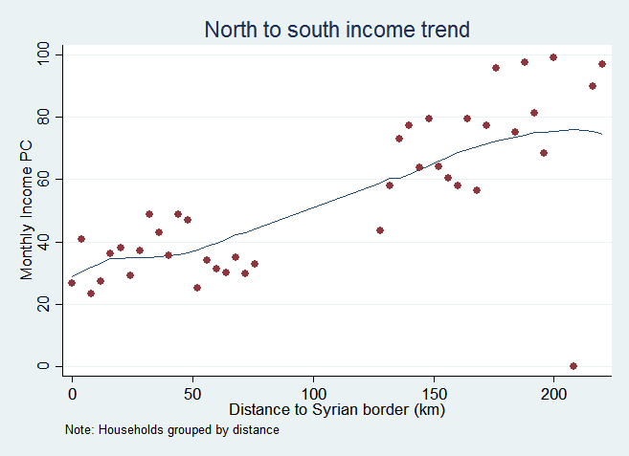
Figure A2: (a) Income relative to study border
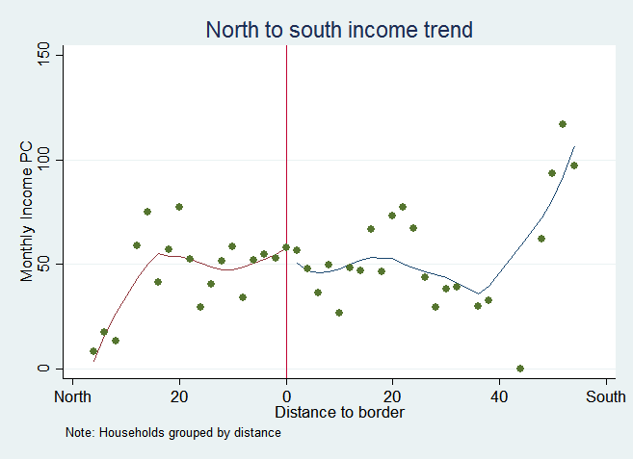
Figure A2: (b) Income relative to study border
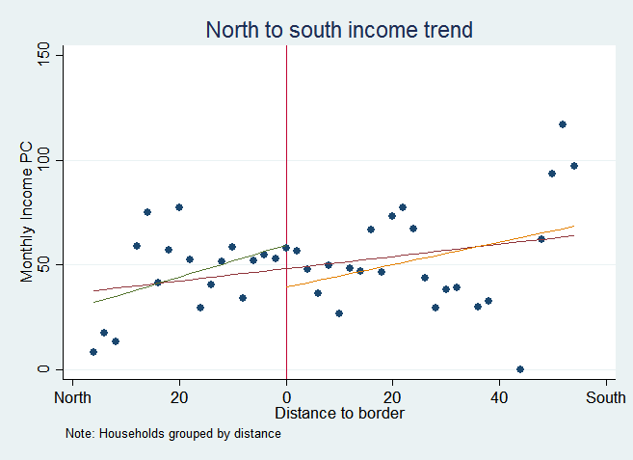

Trends in Food Security
Food security shows a similar trend wherein households to the south of the borders are less vulnerable. Figures A3 and A4 show the relationship between distance the border and the percent of households that are food insecure. Again, there is a consistent although noisy trend of households to the north having higher rates of food insecurity. And again, there is no evidence of a discontinuity in this trend at the border, suggesting that the RDD credibly addresses geographical trends in food security.

Figure A3: Geographic food insecurity trend
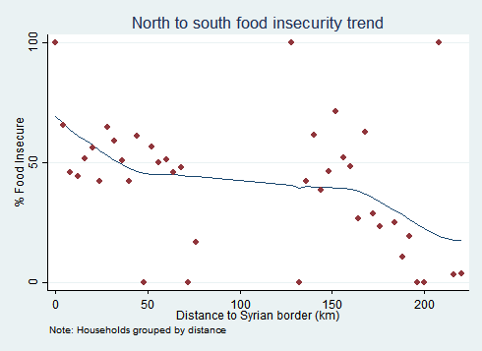

Figure A4: (a) Food security relative to study border
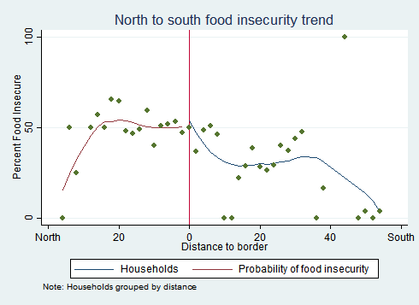
Figure A4: (b) Food security relative to study border
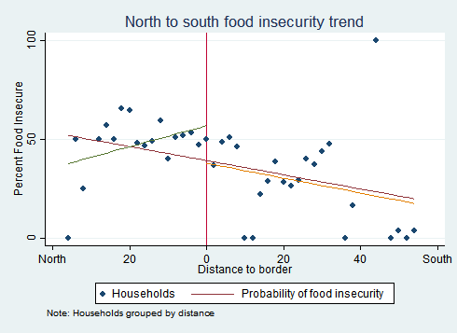

Trends in School Enrollment
We also observe a trend of children to the south being less likely to attend school. The primary goal of the Min Ila program is to encourage children to enroll in school. So, it is important to understand how school enrollment is affected proximity to the border. We find that children’s enrollment decreases slightly when looking at households further south within each pair. This trend appears continuous near and far from the border and there is no jump in school enrollment at the border. These findings suggest that the setting is well suited for a geographic RDD.
Figure A5: Geographic school enrollment trend
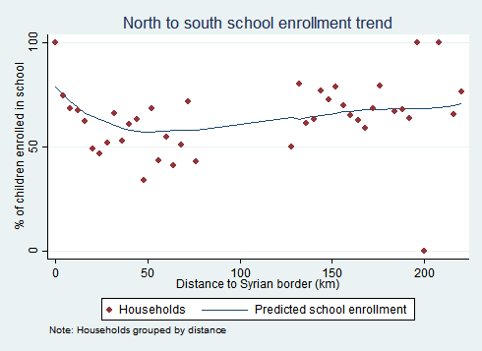

Figure A6: (a) School enrollment relative to study border
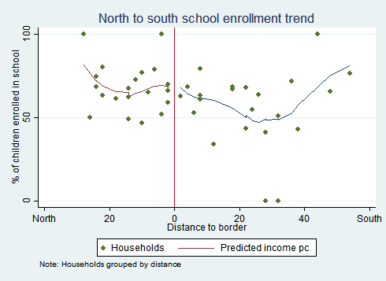

Figure A6: (b) School enrollment relative to study border

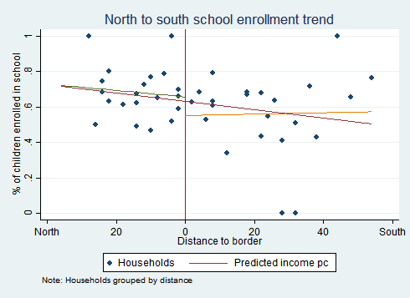

ABOUT AMERICAN INSTITUTES FOR RESEARCH
Established in 1946, with headquarters in Washington, D.C., American Institutes for Research (AIR) is an independent, nonpartisan, not-for-profit organization that conducts behavioral and social science research and delivers technical assistance both domestically and internationally. As one of the largest behavioral and social science research organizations in the world, AIR is committed to empowering communities and institutions with innovative solutions to the most critical challenges in education, health, workforce, and international development.
1000 Thomas Jefferson Street NW
Washington, DC 20007-3835
202.403.5000
www.air.org
LOCATIONS
Domestic
Washington, D.C.
Atlanta, GA
Austin, TX
Baltimore, MD
Cayce, SC
Chapel Hill, NC
Chicago, IL
Columbus, OH
Frederick, MD
Honolulu, HI
Indianapolis, IN
Metairie, LA
Naperville, IL
New York, NY
Rockville, MD
Sacramento, CA
San Mateo, CA
Waltham, MA
International
Egypt
Honduras
Ivory Coast
Kyrgyzstan
Liberia
Tajikistan
Zambia

Statistics Lebanon was contracted by UNICEF to conduct the baseline data collection.
UNICEF and the WFP provided the program to children 15 and 16 years old if their closest school would enroll them, though schools would not guarantee they would accept them. The study will track children in this age range to determine whether they received the transfer, and then analyze this age group separately in the follow-up round if there is a sufficient number of beneficiaries.
WFP, UNHCR, UNICEF and the Lebanon Cash Consortium (LCC) provide humanitarian assistance to vulnerable populations in Lebanon through Cash transfers. They deliver such assistance in Lebanon through creditable and re-chargeable prepaid cards called the “Lebanon One Unified Inter-Organizational System for E-cards” (LOUISE).The goal of this system is to foster cost-efficiency, harmonization and simplification at the beneficiary level. The agencies worked together to develop, organize, and implement the system.
Statistics Lebanon was contracted by UNICEF to conduct the baseline data collection.
UNICEF provided the program to children 15 and 16 years old if their closest school would enroll them, though schools would not guarantee they would accept them. The study will track children in this age range to determine whether they received the transfer, and then analyze this age group separately in the follow-up round if there is a sufficient number of beneficiaries.
https://www.hrw.org/report/2016/07/19/growing-without-education/barriers-education-syrian-refugee-children-lebanon
http://www.unhcr.org/en-us/news/briefing/2015/11/564ef96f6/refugees-lebanon-caught-vicious-debt-cycle.html
https://www.wfp.org/countries/lebanon
Emergency Economies: The Impact of Cash Assistance in Lebanon. IRC August 2014
Nonexperimental designs do not manipulate the selection process to determine who receives the program, while randomized, controlled trials use a lottery process to select who will receive the program and who will not.
Schochet, Peter Z. “Technical Methods Report: Statistical Power for Regression Discontinuity Designs in Education Evaluations. NCEE 2008-4026.” National Center for Education Evaluation and Regional Assistance (2008).
There were 828 households randomly selected for the survey but had left the area so they are not part of the study.
There were 613 households who would not respond to attempts to reach them by phone.
We calculate per capita income by summing household income from wages, self-employment, cash from friends, cash from “support agencies,” food aid, remittances, and sale of assets over the last 30 days, and then dividing by household size.
http://hdl.handle.net/10986/24418
Campbell, D. T., & Stanley, J. C. (1963). Experimental and quasi-experimental designs for research. Hopewell, NJ: Houghton Mifflin.
Gertler, P. J.; Martinez, S., Premand, P., Rawlings, L. B. and Christel M. J. Vermeersch, 2010, Impact Evaluation in Practice: Ancillary Material, The World Bank, Washington DC (www.worldbank.org/ieinpractice)
Lee, D. and T. Lemieux. (2010). “Regression Discontinuity Designs in Economics”, Journal of Economic Literature, 48(2), 281-355.
Importantly, this “geographical RDD” identifies the effect of the program on those households and children living close to the border (the so-called “local treatment effect”), which may or may not be identical to the effect of the program on the full sample in the pilot governorate. Because within governorate differences in the characteristics of Syrian refugees tend to be limited, this issue appears to be of secondary concern.
Keele, L., Lorch, S., Passarella, M., Small, D., & Titiunik, R. (2016). An Overview of Geographically Discontinuous Treatment Assignments with an Application to Children’s Health Insurance. Advances in Econometrics, 38.
Galiani, S., McEwan, P. J., & Quistorff, B. (2016). External and Internal Validity of a Geographic Quasi-Experiment Embedded in Cluster-Randomized Experiment (No. w22468). National Bureau of Economic Research.
Lee, D. and T. Lemieux. (2010). “Regression Discontinuity Designs in Economics”, Journal of Economic Literature, 48(2), 281-355.
Imbens, G. and T. Lemieux. (2008). “Regression Discontinuity Designs : A Guide to Practice”. Journal of Econometrics, 142, 615-635,

